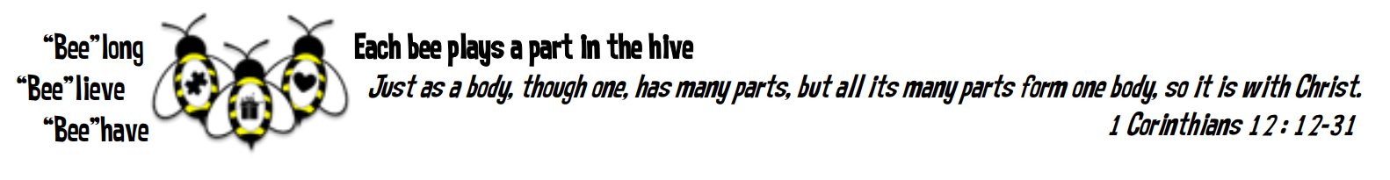
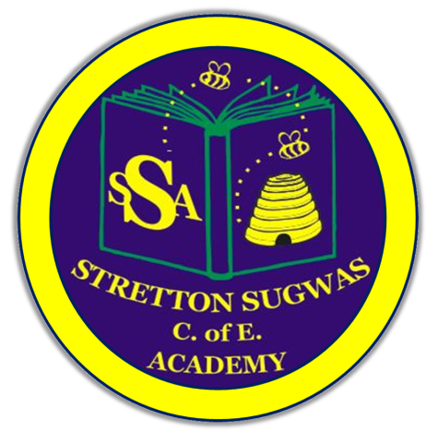

Stretton Sugwas Church of England Academy
Art Policy

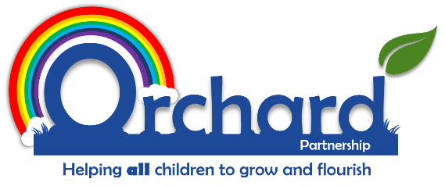

Reviewed: Autumn 2025
Ashleigh Bartle

Introduction: Our Vision
“Each bee plays a part in the hive.”
At Stretton Sugwas Church of England Academy, our Christian ethos is built upon the theme of the Body of Christ, which teaches us that we are all an important part of a team, have a unique role to play and must work together to help others. As a result, we encourage everyone in the school community to belong to a team, believe in themselves and behave in a compassionate way.

Intent: Driven By Our Christian Vision
We believe that our vision should also be reflected throughout our curriculum, as well as being the principle foundation on which our curriculum is built. The Body of Christ passage from the Bible explains that we all have an interdependent and equally valuable role to play in achieving great things together to help others and make a difference. This is what underpins the way in which we have organised our curriculum and monitor its effectiveness.
Our curriculum, in each subject area, should allow all children the opportunity to be included, feel appreciated and develop their voice. It should allow opportunities to work as part of a team and appreciate their role as well as the role of others. Children will gain new skills and knowledge but the challenge of our curriculum is to then put them into practice to use them to make a positive impact.
It is integral to our vision that pupils with SEN and other specific needs are given support to access the curriculum, develop their talents and use them to make an impact appropriate to their needs. Everyone is valued and has a role to play. If our curriculum, policies or practices are not fully inclusive then we will adapt them. Informal feedback from pupils, staff and parents as well as more formal reviews and monitoring will help the school to reflect on what it does to cater for all pupils’ needs, in accordance with its vision.

Implementation: Belong, Believe, Behave
In accordance with our Christian vision, we have structured our curriculum documents into three sections:
- Belong – the skills needed to work as an effective team member and begin to unlock their potential in the relevant subject area (coded in yellow).
- Believe – the subject-specific knowledge and skills needed to develop talents (coded in green).
- Behave – the skills and opportunities needed to apply the subject-specific skills in a meaningful context (coded in blue).
As well as providing a skills progression, entitled our Framework for Flourishing, based on the content of the National Curriculum, we have also included extra skills under the following additional headings:
- Communication and pupil voice
- Teamwork and leadership
- Problem solving and critical thinking
- Creativity and Imagination
- Social action and community involvement
- Global learning and sustainability.
We have deliberately done this to make more explicit and embed the necessary skills we believe are essential in helping pupils to apply what they learn in order to help others and make a positive difference in their communities and wider world – which reiterates our Christian vision. The extra skills we have used within these sections of our curriculum are based on the OXFAM document Education for Global Citizenship: A Guide for Schools.
In addition to our Framework for Flourishing skills progression, we have created curriculum subject Termly Overviews, where we have outlined the specific terms and topics in which National Curriculum knowledge and skills are taught. These continue with the colour coding, where yellow is used to show the context of learning and the motivational entry point for children (belong), green is used for the National curriculum skills (believe) and blue is used for the exit point and opportunities for pupils to apply their learning in a positive way – ideally to impact others (behave).
There is also a white section specifically for cross-curricular links, where connections can be made with other subject areas, allowing for more powerful and memorable learning opportunities.
How children learn in Art
We recognise that children learn best when prior knowledge is built upon and learning is revisited in small steps. To support this:
- We use Kapow Primary’s Art curriculum, which follows a spiral model, revisiting key skills and knowledge over time to embed learning.
- Units are chunked into manageable sequences, ensuring progression and secure understanding.
- Retrieval activities and retention quizzes are built in to support memory and help pupils to revisit and strengthen prior knowledge.
- Opportunities for deliberate practice allow pupils to refine techniques over time.
- Lessons are designed with modelling, scaffolding and clear success criteria, enabling pupils to see what high-quality outcomes look like.
This approach ensures that all pupils are supported in remembering and applying their learning, while also being challenged to take risks and develop independence.

Impact: Belong, Believe, Behave In Action
Crucial to our Christian Vision and educational provision at Stretton Sugwas is the fact that skills and knowledge must be applied within a real-life context. We believe that pupils should be taught how to use their skills to impact the environment around them, wherever realistically possible. Children should be given opportunities to explore the relevance of the skills they are being taught so that it may inspire them.
Assessing the impact of the teaching of the curriculum on pupil learning may take many forms and may be supported by one or more of the following strategies:
- Observing children’s work, individually, in pairs, in groups and in class during whole class teaching.
- Recording of the progress made by children against the learning objectives for each lesson with agreed success criteria.
- Using differentiated, open-ended questions that require children to explain and deepen their understanding.
- Providing effective feedback, both written and verbal, to engage children with their learning and to provide opportunities for self-assessment, consolidation and target setting.
- Book moderation and monitoring of outcomes of work, to evaluate the range and balance of work and to ensure that tasks meet the needs of different learners.
- Encouraging children to assess and evaluate both their own work and that of other pupils to appreciate how they can improve their performance and set their targets for the future.
- Formally reporting each child’s attainment and progress to parents at the end of the year in the child’s end of year report.
- Document analysis, pupil interviews, book trawls and lesson observations from subject leaders.
- Quizzes and meaningful activities for children to celebrate and showcase their learning.
- Parental questionnaires.
This is a working document and practitioners may change or adapt specific skills or ideas based on helping increase the ways that children engage with their learning, helping them to see where they belong, believe in their skills and behave in a way that uses their learning to impact the world around them.

Inclusion: SEND And Helping All Learners To Achieve In Art
Our Christian vision challenges all subject leaders to reflect on ensuring that the Art curriculum helps all pupils to belong and access learning, appropriate to their needs and abilities. Inclusion and belonging is a thread that runs through every area of the school enhanced by collaboration between senior leaders, subject leaders, the SENCO, class teachers, support staff, external agencies, parents and most importantly, the child. At Stretton Sugwas Church of England Academy, every teacher is a teacher of SEND and every leader is a leader of SEND.

Special Educational Needs and Disability (SEND) – Including the Lowest 20% of Learners
We firmly believe that Quality First Teaching is the solid foundation on which effective SEND provision is built. The first step to children having access to a broad and balanced Art curriculum is through appropriate differentiation by skilled and nurturing teaching staff, who have ambitious expectations of their own teaching and students’ learning. Differentiation is not a simple case of providing different worksheets, for example. Differentiation is adapting the work, success criteria or support given to help children achieve or make progress.
Differentiation – or adaptations – may include:
- Alternative tasks
- Different objectives or goals within a task
- Resources or learning aids
- Amount of adult support within a task
- Frequency of monitoring within a session
- Time given to complete tasks
- Style of language used
- Style of questioning used
- Use of peer support
- Classroom organisation and grouping
- Level or style of feedback given
Differentiation takes many forms to help learners to belong within lessons, believe in their ability and behave in a way that applies their skills. Further support to help inclusion and overall pupil progress in this subject area may include:
- Targeted intervention programmes, which have a proven and measurable impact on progress.
- Specific 1:1 or small group intervention, including support from a Learning Mentor.
- Celebration of achievement, as well as attainment.
- Time given, as appropriate, to any emotional or behavioural support that may in turn be barriers to learning in this subject area.
- Monitoring pupil attitudes to subject and using pupil voice to ensure that learners have ownership of subject area/tasks.
- Specific enrichment activities, visits or events planned/attended in order to suit the needs and interests of specific groups of learners.
- Pupil progress meetings, involving the pupil(s) and any relevant adults.
- Data analysis, whether this is quantitative performance data from tests, for example, or qualitative data from questionnaires or monitoring observations.
- The provision of good quality and relevant training for all staff members.

Other Pupil Groups – Including More Able and Talented (MAT) and the Highest 20% of Learners
We believe that all children have individual gifts, interests and talents. Some children may exhibit a skill that is advanced in comparison to their peers. As a result, such pupils will require a higher level of challenge in order for them to belong, be included within Art sessions and have their needs met. More able and talented pupils (MAT) will also receive differentiation and support appropriate to their needs.
Adapting tasks and providing opportunities to help all children to achieve well will also depend on the diversity of the groups of learners that are represented at Stretton Sugwas Church of England Academy.
Groupings of learners that could identify trends, spikes or dips in overall progress may include:
- Forces children
- Gender
- Behavioural needs
- Children with emotional needs
- EAL children
- Age (i.e. summer born)
- Attendance
- Family support
- LAC
- Ethnicity
- Those experiencing tragedy or loss
- Low self-esteem
This list is not exhaustive and neither are the methods mentioned in how learners can be catered for in this subject area. We are a listening school and are constantly reflecting on feedback from adults and children, with the constant goal of helping all learners to belong, believe and behave.

