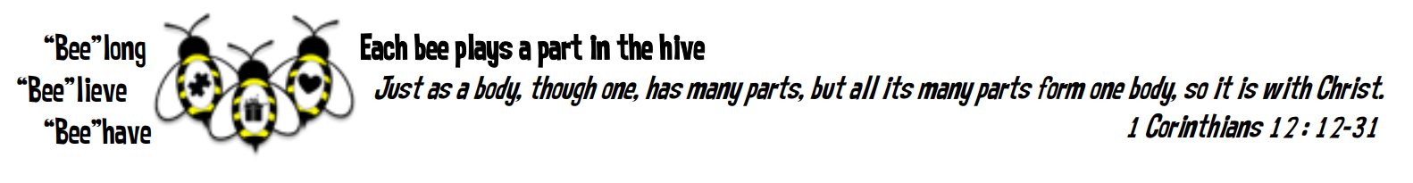
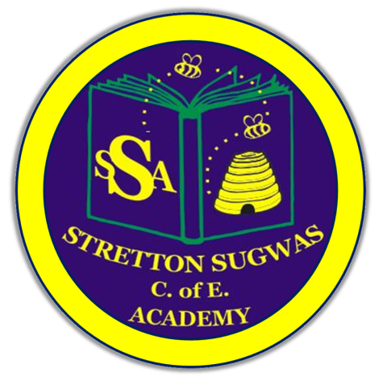

Stretton Sugwas Church of England Academy
Curriculum Overview
PSHE

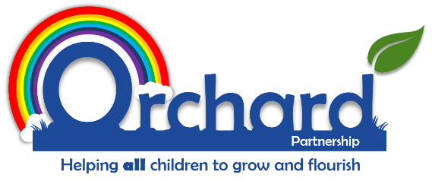

Reviewed: Autumn 2025
C O’Reilly

Introduction: Our Vision

“Each bee plays a part in the hive.”

At Stretton Sugwas Church of England Academy, our Christian ethos—rooted in the Body of Christ—celebrates every individual’s unique role in the community. This vision underpins our PSHE curriculum, which is designed to help pupils belong to a team, believe in their potential, and behave with compassion and purpose. Through PSHE, pupils develop a sense of identity, responsibility, and voice, enabling them to flourish as part of a supportive and inclusive school environment.

Intent: Driven By Our Christian Vision

We believe that our vision should also be reflected throughout our curriculum, as well as being the principle foundation on which our curriculum is built. The Body of Christ passage from the Bible explains that we all have an interdependent and equally valuable role to play in achieving great things together to help others and make a difference. This is what underpins the way in which we have organised our curriculum and monitor its effectiveness.

Implementation: Belong, Believe, Behave

Our curriculum is structured around the three pillars of our vision:
- Belong – Pupils develop teamwork, empathy, and a sense of community through collaborative tasks and inclusive practices.
- Believe – Knowledge and skills are built progressively, with scaffolded learning and vocabulary development to support mastery.
- Behave – Pupils apply their learning in meaningful contexts, such as social action projects, peer mentoring, and community engagement.

How children learn in PSHE
Our PSHE curriculum is built on a spiral structure (Kapow), ensuring retrieval, progression, and deepening understanding over time. It is designed to reflect our Christian vision and the belief that every child has a valuable role to play. Learning is chunked and scaffolded to support cognitive development, with strategies such as pre-teaching, retention quizzes, and revisiting key concepts to reduce cognitive overload and enhance long-term retention.
The challenge of our curriculum is to then put them into practice to use them to make a positive impact.

EYFS Links
PSHE is closely linked to the Personal, Social and Emotional development area of learning in EYFS. In EYFS PSE is embedded through play-based learning, emotional literacy, and social development activities that lay the foundation for belonging, believing, and behaving. Children explore relationships, self-awareness, and community through stories, role play, and expressive language.

Inclusion and SEND
It is integral to our vision that pupils with SEN and other specific needs are given support to access the PSHE curriculum, develop their talents and use them to make an impact appropriate to their needs. Everyone is valued and has a role to play. If our curriculum, policies or practices are not fully inclusive then we will adapt them. Informal feedback from pupils, staff and parents as well as more formal reviews and monitoring will help the school to reflect on what it does to cater for all pupils’ needs, in accordance with its vision. Inclusion is central to our curriculum. Differentiation may include adapted tasks, tailored resources, peer support, and targeted interventions to ensure all learners—including those with SEND—can access and thrive in PSHE.
Our Christian vision challenges all subject leaders to reflect on ensuring that the PSHE curriculum helps all pupils to belong and access learning, appropriate to their needs and abilities. Inclusion and belonging is a thread that runs through every area of the school enhanced by collaboration between senior leaders, subject leaders, the SENCO, class teachers, support staff, external agencies, parents and most importantly, the child. At Stretton Sugwas Church of England Academy, every teacher is a teacher of SEND and every leader is a leader of SEND.

Differentiation- or adaptations- may include:
- Alternative tasks
- Different objectives or goals within a task
- Resources or learning aids
- Amount of adult support within a task
- Frequency of monitoring within a session
- Time given to complete tasks
- Style of language used
- Style of questioning used
- Use of peer support
- Classroom organisation and grouping
- Level or style of feedback given

More able/highest 20%
More Able and Talented (MAT) pupils and the highest 20% are challenged through higher-level tasks, opportunities for extension, and leadership roles within discussions and projects.

Vocabulary Development
Vocabulary is explicitly taught and rehearsed using Voice 21 strategies, enabling pupils to articulate ideas confidently through critique, discussion, and reflection. Key vocabulary will be displayed in lessons and modelled throughout the learning period.

Technology in PSHE
Technology enhances PSHE by:
- Recording/photographing discussions and role play
- Accessing online resources
- Supporting inclusions through adapted resources and communication tools
- Sharing what we have learnt in PE with parents through our Facebook page

Cultural links to Hereford
Cultural links are woven into the curriculum, with opportunities to engage in community projects. We also ensure children are taught about water safety as we are aware of the strong presence of the River Wye in Herefordshire and the Sugwas pools on the doorstep of our school. We also know that some of our children walk/cycle to school so we teach road safety and bike ability practising in the area around school.

Impact: Belong, Believe, Behave In Action

Subject Leader Monitoring

The PSHE subject leader monitors impact through:
- Photographic and video evidence of lessons and events
- Pupil voice interviews to gather feedback and inform improvements
- Reports to governors on curriculum delivery, inclusion, and outcomes

The methods mentioned for how children can learn, develop and be catered for in this subject area are not exhaustive. We are a listening school and are constantly reflecting on feedback from adults and children, with the constant goal of helping all learners to belong, believe and behave.

Assessing the impact of the teaching of the curriculum on pupil learning may take many forms and may be supported by one or more of the following strategies:
- Observing children’s work, individually, in pairs, in groups and in class during whole class teaching.
- Recording of the progress made by children against the learning objectives for each lesson with agreed success criteria.
- Using differentiated, open-ended questions that require children to explain and deepen their understanding.
- Providing effective feedback, both written and verbal, to engage children with their learning and to provide opportunities for self-assessment, consolidation and target setting.
- Book moderation and monitoring of outcomes of work, to evaluate the range and balance of work and to ensure that tasks meet the needs of different learners.
- Encouraging children to assess and evaluate both their own work and that of other pupils to appreciate how they can improve their performance and set their targets for the future.
- Formally reporting each child’s attainment and progress to parents at the end of the year in the child’s end of year report.
- Document analysis, pupil interviews, book trawls and lesson observations from subject leaders.
- Quizzes and meaningful activities for children to celebrate and showcase their learning.
- Parental questionnaires.

This is a working document and practitioners may change or adapt specific skills or ideas based on helping increase the ways that children engage with their learning, helping them to see where they belong, believe in their skills and behave in a way that uses their learning to impact the world around them.

