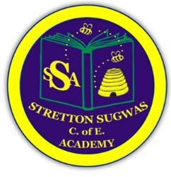

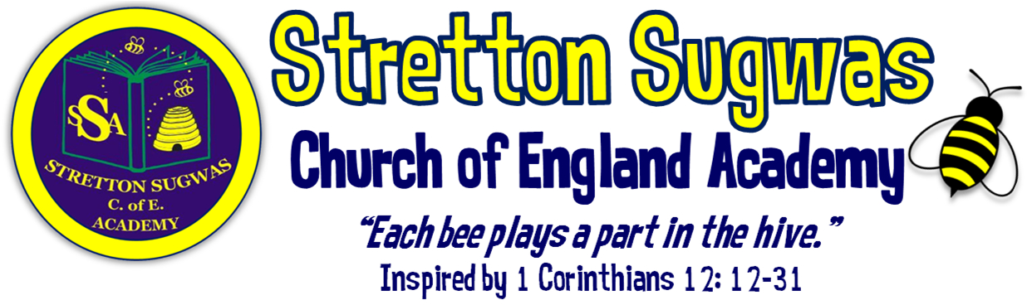

Subject Leader Action Plan: RE
How can we help all stakeholders at Stretton to “Bee”long, “Bee”lieve in their skills and “Bee”have in a way that helps others?
Scriptural Background: 1 Corinthians 12 v12-31 (NIV)
Just as a body, though one, has many parts, but all its many parts form one body, so it is with Christ. ¹³For we were all baptized by one Spirit so as to form one body-whether Jews or Gentiles, slave or free-and we were all given the one Spirit to drink. ¹⁴Even so the body is not made up of one part but of many. ¹⁵Now if the foot should say, "Because I am not a hand, I do not belong to the body," it would not for that reason stop being part of the body. ¹⁶And if the ear should say, "Because I am not an eye, I do not belong to the body," it would not for that reason stop being part of the body. ¹⁷If the whole body were an eye, where would the sense of hearing be? If the whole body were an ear, where would the sense of smell be? ¹⁸But in fact God has placed the parts in the body, every one of them, just as he wanted them to be. ¹⁹If they were all one part, where would the body be? ²⁰As it is, there are many parts, but one body. ²¹The eye cannot say to the hand, "I don't need you!" And the head cannot say to the feet, "I don't need you!" ²² On the contrary, those parts of the body that seem to be weaker are indispensable, ²³ and the parts that we think are less honourable we treat with special honour. And the parts that are unpresentable are treated with special modesty, ²⁴ while our presentable parts need no special treatment. But God has put the body together, giving greater honour to the parts that lacked it, ²⁵ so that there should be no division in the body, but that its parts should have equal concern for each other. ²⁶ If one part suffers, every part suffers with it; if one part is honoured, every part rejoices with it.²⁷ Now you are the body of Christ, and each one of you is a part of it. ²⁸ And God has placed in the church first of all apostles, second prophets, third teachers, then miracles, then gifts of healing, of helping, of guidance, and of different kinds of tongues. ²⁹ Are all apostles? Are all prophets? Are all teachers? Do all work miracles? ³⁰ Do all have gifts of healing? Do all speak in tongues^{[d]}? Do all interpret? ³¹ Now eagerly desire the greater gifts.

Action Plan Summary

Based on evidence from monitoring, feedback and school priorities, the top four priorities for this subject are:
- Ensure RE assessment is rigorous and consistent, fully embedded within Arbor, and moderated across staff.
- Stretch more able pupils through deeper thinking and questioning, ensuring at least 80% feel challenged.
- Strengthen local cultural links with faith groups and organisations, and broaden opportunities through clubs and visits.
- Develop pupils’ oracy and vocabulary in RE, aligning with SDP priority for Voice21.

Subject Lead: Ben Ford
Date: September 2025

Priority 1: Assessment (linked to SDP Target 1)

SMART Target:
By July 2026, all staff will implement rigorous assessment in RE, using Pollen8 moderation sheets and Arbor to record termly data, with subject leader triangulating evidence (bookletss, pupil voice, lessons) at least twice per term.
Rationale | Success Criteria | Actions | Who | Resources | Timescale | Monitoring | Reporting
Need for robust, consistent assessment across foundation subjects. Staff new to role require clarity. Arbor must capture data effectively. | • 100% of staff trained on RE assessment policy.  • 3 moderation sessions completed across the year.  • 100% of termly data entries into Arbor completed on time.  • Triangulation evidence gathered twice per term. | • Train staff (esp. new staff) on RE assessment.  • Introduce Pollen8 sheets for moderation.  • Termly Arbor data input.  • Triangulate assessment using book looks, pupil voice, lesson observations. | Subject Leader, SLT, new staff mentor | Pollen8 sheets, Arbor, time for staff training & moderation | Sept 2025 – July 2026 | Termly monitoring by subject leader & SLT | Staff meeting feedback; governor reports; triangulation records

Priority 2: Stretch More Able Pupils (linked to SDP Target 2)

SMART Target:
By July 2026, 80% of more able pupils will evidence deeper thinking in RE through challenge tasks, higher-order questioning, and critique, as shown by book looks, pupil voice, and outcomes.
Rationale | Success Criteria | Actions | Who | Resources | Timescale | Monitoring | Reporting
SDP target focuses on challenge for higher attainers. Evidence needed of deeper thinking in RE. | • 2 staff CPD sessions on deeper thinking delivered by Christmas.  • 100% of RE units include labelled “Extension / More Able” task.  • 80%+ of more able pupils report challenge in pupil voice.  • 30%+ of work samples show deeper thinking. | • Deliver CPD on questioning & challenge.  • Build extension tasks into RE Today planning.  • Use pupil voice to evaluate challenge.  • Monitor books for evidence of depth. | Subject Leader, All staff | RE Today extension tasks, CPD resources | Sept 2025 – July 2026 | Mid-year & end-year monitoring | Governor reports; staff meeting feedback

Priority 3: Local Links & Broader Offer (linked to SDP Target 3)

SMART Target:
By July 2026, the school will establish at least 3 new partnerships with local schools, organisations or faith representatives, run 2 in-school artist workshops, 2 places of worship visits, and launch an after-school Spirituality club or similar with 15+ regular pupils.
Rationale | Success Criteria | Actions | Who | Resources | Timescale | Monitoring | Reporting
Local cultural links enhance engagement, identity and aspiration. Broader extracurricular offer enriches curriculum. | • 3+ local partnerships formed.  • 2 workshops delivered.  • 2 external visits completed.  • After-school club running with 15+ pupils.  • School work displayed in public space. | • Contact local schools, SACRE, faith groups.  • Plan 2 workshops with schools or faith reps.  • Organise places of worship visits.  • Launch after-school Spirituality club.  • Showcase pupil work in local SACRE bulletin or diocese newsletter. | Subject Leader, School Visits Co-ordinator, PTA | Budget £500; links with local faith reps; transport for visits | Sept 2025 – July 2026 | Mid-year review of partnerships & visits | Reports to SLT/governors; pupil feedback

Priority 4: Oracy & Vocabulary (linked to SDP Target 4 – Voice21)

SMART Target:
By July 2026, 80% of pupils will confidently use Tier 2 and Tier 3 RE vocabulary in speech or writing, with oracy tasks embedded in 100% of RE lessons.
Rationale | Success Criteria | Actions | Who | Resources | Timescale | Monitoring | Reporting
SDP focus on oracy and Voice21. RE provides rich opportunities for vocabulary and reflection. | • Vocabulary progression list for RE produced by Term 1.  • 100% of lessons include structured oracy task.  • 80%+ pupils use Tier 2/3 vocabulary accurately in pupil voice/written work.  • Vocabulary seen in books/displays. | • Identify and display key RE vocabulary.  • Provide sentence stems for reflection/discussion.  • Embed speaking & listening tasks in RE Today lessons.  • Monitor vocabulary in pupil work & observations. | Subject Leader, All staff | Vocabulary lists, Voice21 strategies | Sept 2025 – July 2026 | Lesson observations; pupil voice | Termly subject leader reports; governor updates

Implementation Timeline
- Term 1: New staff induction on assessment; vocabulary list developed; after-school club launched; CPD on deeper thinking scheduled; initial faith group contact made.
- Term 2: First moderation using Pollen8; first triangulation; first place of worship visit/workshop; CPD delivered.
- Term 3: Second moderation & triangulation; after-school club review; second place of worship visit/workshop; pupil work displayed; review vocabulary/oracy.

Research & Evidence Base
- Assessment: Moderation using shared frameworks (e.g. Pollen8) increases reliability of judgements and staff confidence (Ofsted; EEF).
- Retrieval & Spiral Curriculum: RE Today’s spiralled structure builds secure memory and progression, supported by cognitive science research (EEF, 2022).
- Challenge for More Able: Enquiry-based, higher-order questioning and critique tasks lead to improved outcomes for more able learners (DfE Challenge the Most Able, 2015).
- Local Cultural Links: Research highlights that local and cultural relevance improves engagement and attainment (EEF Toolkit – Arts Participation +2 months).
- Oracy & Vocabulary: Explicit vocabulary instruction and structured talk activities improve comprehension and attainment across subjects (EEF Oral Language Interventions, +6 months).

Impact Statement – RE 2025–26
By the end of the 2025–26 academic year, RE provision at Stretton Sugwas CE Academy will be stronger, more consistent and inclusive. The introduction of rigorous assessment procedures, including Pollen8 moderation sheets and termly Arbor data entry, will ensure teacher judgements are accurate and consistent across the school. This will allow leaders and governors to monitor attainment and progress effectively, and provide targeted support where needed. More able pupils will be stretched through carefully planned challenge questions, extension tasks and opportunities for critique. Evidence from pupil voice and book looks will demonstrate that at least 80% of more able pupils feel challenged, with a measurable increase in the proportion of work showing deeper thinking and independent creativity. Our curriculum will be further enriched through strengthened partnerships with local faith groups, schools and organisations. Pupils will take part in at least two workshops and two place of worship or community visits, broadening their cultural capital and providing real-life contexts for their RE learning. The launch of an after-school RE club will give at least 15 children additional opportunities to develop their skills, showcase their work, and deepen their enthusiasm for the subject. Through the focus on oracy and vocabulary, pupils will be explicitly taught and expected to use Tier 2 and Tier 3 RE language to articulate ideas, reflect on work, and present their own opinions. By the end of the year, at least 80% of pupils will confidently use subject-specific vocabulary in both verbal and written contexts, strengthening both their communication and their understanding of RE. Overall, these actions will ensure that RE at Stretton Sugwas CE Academy is inclusive, ambitious and inspiring. Pupils will leave each year group with the knowledge, skills and cultural awareness to flourish, in line with the school’s Christian vision: to belong, believe and behave in a way that uses their learning to make a positive difference to the world around them.

