


Stretton Sugwas Church of England Academy
Curriculum Overview
Maths

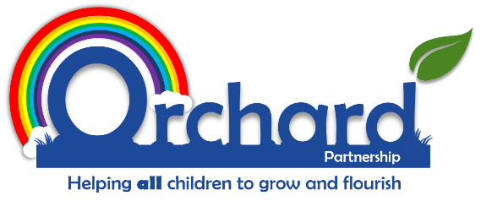

Reviewed: September 2025
L Cuss

Intent
At Stretton Sugwas Church of England Academy, we believe that Mathematics is a key skill that helps us to make sense of the world around us. It enables children to understand and appreciate relationships and pattern in both number and space in their everyday lives. Through their growing knowledge and understanding, children learn to understand and apply their knowledge to solve real life problems.
​
At Stretton Sugwas Church of England Academy, we also believe that Mathematics equips children with a uniquely powerful set of tools to understand and change the world. These tools include logical reasoning, problem-solving skills and the ability to think in abstract ways.
​
Mathematics is important in everyday life, many forms of employment, science and technology, medicine, the economy, the environment and development and in public decision-making. Different cultures have contributed to the development and application of mathematics. Today, the subject transcends cultural boundaries, and its importance is universally recognised.

Implementation
At Stretton Sugwas Church of England Academy, we use White Rose Maths mastery approach to maths teaching. The research-driven teaching and learning scheme puts numbers first, puts depth before breadth and encourages a collaborative approach to learning which develops fluency, reasoning and problem-solving. This ensures that all children at Stretton Sugwas Church of England Academy, have the skills they need to become competent and confident mathematicians.

To develop and secure number sense, we use White Rose Fluency Bee in Years 1-4. Fluency Bee is a structured teaching programme that builds children’s confidence through varied and frequent practice. Key representations alongside emphasis on mathematical talk and a hands-on, practical approach builds and secures number sense.

Throughout our teaching, we embed a mastery using the Concrete Pictorial Abstract (CPA) approach. Research shows that when children are introduced to a new concept, working with concrete physical resources and pictorial representations leads to a better understanding of abstract concepts. We use CPA throughout our schemes of learning.
​
All lessons are carefully planned and adapted to suit the needs of all differing mathematical ability, and all children are challenged through a wide range of strategies including individual, paired or small group work. We use classroom assistants to support targeted groups and to provide in situ feedback to ensure that work is matched to the needs of individuals.

Teacher ensure that

- all children are given opportunities for: practical activities, role play and mathematical board games
- the development of mental and oral strategies with an emphasis on speed recall of number bonds and multiplication tables
- the development of mathematical vocabulary
- problem solving
- individual, group and whole class discussions and activities
- open and closed tasks
- a range of methods of calculating e.g. mental, pencil and paper
- understand mathematics through a process of enquiry and experiment
- Daily fluency bee sessions in Years 1-4
- Daily arithmetic lessons in KS2.
- regular use of ICT games and apps to reinforce, develop and enthuse learning e.g. Doodle Maths and Doodle Tables

Impact
The impact of our Mathematics curriculum is measured through both formative and summative assessments. Each lesson includes guidance for assessing pupils against specific learning objectives, ensuring ongoing feedback and the opportunity to identify gaps in understanding. Teachers identify and quickly address misconceptions, enable the forging of connections between concepts, and recognise opportunities for challenge and in-depth reasoning.

Summative assessments are used to evaluate pupils’ knowledge at the end of each unit. Our assessment for learning (AfL) model includes live marking, self and peer assessments, and teacher observations. This approach enables teachers to track progress, identify areas for development, and provide targeted pre-teach opportunities and interventions where needed. Pupil progress and attainment are carefully analysed, and the data is used formatively to direct access arrangements, teacher planning and content revision.

We expect that pupils will meet the relevant Early Learning Goals in the EYFS and achieve the end-of-key-stage expectations outlined in the National Curriculum for Mathematics by the end of Key Stage 1 and Key Stage 2. Through their learning, they will be equipped with the knowledge and skills to confidently progress to Key Stage 3 and beyond, with a lasting interest in and appreciation for Mathematics.

This policy reflects our commitment to delivering a high-quality Mathematics education that supports our pupils’ development as reflective, resourceful, and resilient learners, in line with the vision and ethos of Stretton Sugwas Church of England Academy.

