
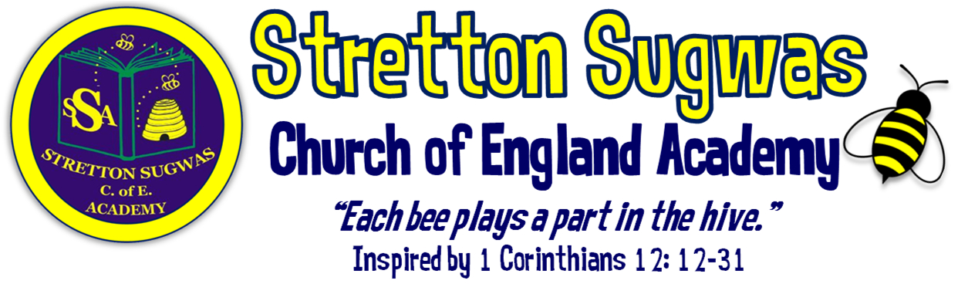
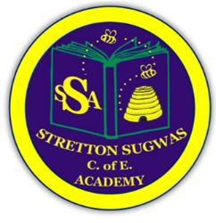

Subject Leader Action Plan: Music

How can we help all stakeholders at Stretton to “Bee”long, “Bee”lieve in their skills and “Bee”have in a way that helps others?
Scriptural Background: 1 Corinthians 12 v12-31 (NIV)
Just as a body, though one, has many parts, but all its many parts form one body, so it is with Christ. ¹³For we were all baptized by one Spirit so as to form one body-whether Jews or Gentiles, slave or free-and we were all given the one Spirit to drink. ¹⁴Even so the body is not made up of one part but of many. ¹⁵Now if the foot should say, "Because I am not a hand, I do not belong to the body," it would not for that reason stop being part of the body. ¹⁶And if the ear should say, "Because I am not an eye, I do not belong to the body," it would not for that reason stop being part of the body. ¹⁷If the whole body were an eye, where would the sense of hearing be? If the whole body were an ear, where would the sense of smell be? ¹⁸But in fact God has placed the parts in the body, every one of them, just as he wanted them to be. ¹⁹If they were all one part, where would the body be? ²⁰As it is, there are many parts, but one body. ²¹The eye cannot say to the hand, "I don't need you!" And the head cannot say to the feet, "I don't need you!" ²² On the contrary, those parts of the body that seem to be weaker are indispensable, ²³ and the parts that we think are less honourable we treat with special honour. And the parts that are unpresentable are treated with special modesty, ²⁴ while our presentable parts need no special treatment. But God has put the body together, giving greater honour to the parts that lacked it, ²⁵ so that there should be no division in the body, but that its parts should have equal concern for each other. ²⁶ If one part suffers, every part suffers with it; if one part is honoured, every part rejoices with it.²⁷ Now you are the body of Christ, and each one of you is a part of it. ²⁸ And God has placed in the church first of all apostles, second prophets, third teachers, then miracles, then gifts of healing, of helping, of guidance, and of different kinds of tongues. ²⁹ Are all apostles? Are all prophets? Are all teachers? Do all work miracles? ³⁰ Do all have gifts of healing? Do all speak in tongues^{[d]}? Do all interpret? ³¹ Now eagerly desire the greater gifts.

Action Plan Summary
Based on monitoring, feedback, and school priorities, the top four priorities for Music are:
- Ensure Music assessment is rigorous and consistent, embedded within Arbor, and moderated across staff.
- Stretch more able pupils through composition, performance, and musical analysis, ensuring at least 80% feel challenged.
- Strengthen local cultural links with musicians, venues, and organisations, and broaden opportunities through clubs and performances.
- Develop pupils’ oracy and vocabulary in Music, aligning with SDP priority for Voice21.
Subject Lead: Gemma Cartwright
Date: September 2025

Priority 1: Assessment (linked to SDP Target 1)
SMART Target:
By July 2026, all staff will implement rigorous assessment in Music, using Pollen8 moderation sheets and Arbor to record termly data, with the subject leader triangulating evidence (books, pupil voice, lessons) at least twice per term.
Rationale | Success Criteria | Actions | Who | Resources | Timescale | Monitoring | Reporting
Need for robust, consistent assessment across foundation subjects. Staff new to role require clarity. Arbor must capture data effectively. | • 100% staff trained on Music assessment policy.  • 3 moderation sessions completed.  • 100% termly data entries into Arbor.  • Triangulation evidence gathered twice per term. | • Train staff on Music assessment.  • Introduce Pollen8 sheets.  • Termly Arbor input.  • Triangulate using lesson obs, pupil voice, recordings. | Subject Leader, SLT, new staff mentor | Pollen8 sheets, Arbor, CPD time | Sept 2025 – July 2026 | Termly monitoring | Staff meeting feedback; governor reports

Priority 2: Stretch More Able Pupils (linked to SDP Target 2)
SMART Target:
By July 2026, 90% of more able pupils will evidence deeper musical thinking through composition, performance, and analysis, as shown by pupil voice, recordings, and outcomes.
Rationale | Success Criteria | Actions | Who | Resources | Timescale | Monitoring | Reporting
SDP target focuses on challenge for higher attainers. Evidence needed of deeper thinking in Music. | • 1 CPD session on musical challenge delivered.  • 100% units include “Extension / More Able” task.  • 80%+ pupils report challenge.  • 30%+ work samples show depth. | • Deliver CPD on musical analysis & composition.  • Build extension tasks into planning.  • Use pupil voice.  • Monitor recordings/work. | Subject Leader, All staff | CPD resources, instruments, software | Sept 2025 – July 2026 | Mid-year & end-year | Governor reports; staff feedback

Priority 3: Local Links & Broader Offer (linked to SDP Target 3)
SMART Target:
By July 2026, the school will establish at least 3 new partnerships with local musicians/organisations, run 2 in-school workshops, 2 external performances/visits, and launch a Music club with 15+ regular pupils.
Rationale | Success Criteria | Actions | Who | Resources | Timescale | Monitoring | Reporting
Local cultural links enhance engagement, identity and aspiration. Broader extracurricular offer enriches curriculum. | • 2+ partnerships formed.  • 1 workshop delivered.  • 2 visits completed.  • Music club with 15+ pupils.  • School performance in local venue. | • Contact local organisations (Hereford Music Festival, Courtyard, HVM, local choirs).  • Plan workshop.  • Organise visits.  • Launch club.  • Showcase pupil performances. | Subject Leader, School Visits Co-ordinator, PTA | Budget £500; links with musicians; transport | Sept 2025 – July 2026 | Mid-year review | SLT/governor reports; pupil feedback

Priority 4: Oracy & Vocabulary (linked to SDP Target 4 – Voice21)
SMART Target:
By July 2026, 80% of pupils will confidently use Tier 2 and Tier 3 Music vocabulary in speech or writing, with oracy tasks embedded in 100% of Music lessons.
Rationale | Success Criteria | Actions | Who | Resources | Timescale | Monitoring | Reporting
SDP focus on oracy and Voice21. Music provides rich opportunities for vocabulary and critique. | • Vocabulary progression list produced.  • 100% lessons include oracy task.  • 80%+ pupils use vocabulary accurately.  • Vocabulary seen in work/displays. | • Identify/display key vocabulary.  • Provide sentence stems for critique.  • Embed speaking tasks in lessons.  • Monitor pupil work. | Subject Leader, All staff | Vocabulary lists, Voice21 strategies | Sept 2025 – July 2026 | Observations; pupil voice | Termly reports; governor updates

Implementation Timeline
- Term 1: Staff induction on assessment; vocabulary list developed; Music club launched; CPD on musical challenge scheduled; initial musician contact made.
- Term 2: First moderation; first triangulation; first workshop/visit; CPD delivered.
- Term 3: Second moderation & triangulation; club review; pupil performance locally; review vocabulary/oracy.

Research & Evidence Base
- Assessment: Moderation using shared frameworks (e.g. Pollen8) increases reliability of judgements and staff confidence (Ofsted; EEF).
- Retrieval & Spiral Curriculum: Kapow’s spiralled structure builds secure memory and progression, supported by cognitive science research (EEF, 2022).
- Challenge for More Able: Enquiry-based, higher-order questioning and critique tasks lead to improved outcomes for more able learners (DfE Challenge the Most Able, 2015).
- Local Cultural Links: Research highlights that local and cultural relevance improves engagement and attainment (EEF Toolkit – Arts Participation +2 months).
- Oracy & Vocabulary: Explicit vocabulary instruction and structured talk activities improve comprehension and attainment across subjects (EEF Oral Language Interventions, +6 months).

Impact Statement – Music 2025–26
By the end of the 2025–26 academic year, Music provision at Stretton Sugwas CE Academy will be stronger, more consistent and inclusive. The introduction of rigorous assessment procedures, including Pollen8 moderation sheets and termly Arbor data entry, will ensure teacher judgements are accurate and consistent across the school. This will allow leaders and governors to monitor attainment and progress effectively, and provide targeted support where needed. More able pupils will be stretched through carefully planned composition tasks, performance opportunities, and musical analysis. Evidence from pupil voice and recordings will demonstrate that at least 80% of more able pupils feel challenged, with a measurable increase in the proportion of work showing deeper thinking and independent creativity. Our curriculum will be further enriched through strengthened partnerships with local musicians, venues and organisations. Pupils will take part in at least one workshop and two external visits, broadening their cultural capital and providing real-life contexts for their musical learning. The launch of an after-school Music club will give at least 15 children additional opportunities to develop their skills, showcase their work, and deepen their enthusiasm for the subject. Through the focus on oracy and vocabulary, pupils will be explicitly taught and expected to use Tier 2 and Tier 3 Music language to articulate ideas, critique performances, and present their own compositions. By the end of the year, at least 80% of pupils will confidently use subject-specific vocabulary in both verbal and written contexts, strengthening both their communication and their understanding of Music. Overall, these actions will ensure that Music at Stretton Sugwas CE Academy is inclusive, ambitious and inspiring. Pupils will leave each year group with the knowledge, skills and cultural awareness to flourish, in line with the school’s Christian vision: to belong, believe and behave in a way that uses their learning to make a positive difference to the world around them.

