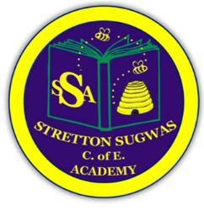

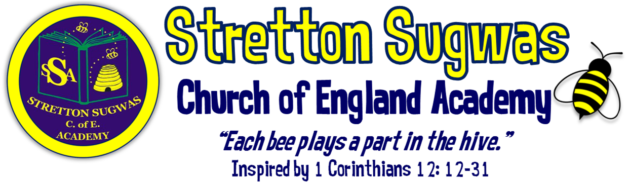

Subject Leader Action Plan: Geography
How can we help all stakeholders at Stretton to “Bee”long, “Bee”lieve in their skills and “Bee”have in a way that helps others?
Scriptural Background: 1 Corinthians 12 v12-31 (NIV)
Just as a body, though one, has many parts, but all its many parts form one body, so it is with Christ. ¹³For we were all baptized by one Spirit so as to form one body-whether Jews or Gentiles, slave or free-and we were all given the one Spirit to drink. ¹⁴Even so the body is not made up of one part but of many. ¹⁵Now if the foot should say, "Because I am not a hand, I do not belong to the body," it would not for that reason stop being part of the body. ¹⁶And if the ear should say, "Because I am not an eye, I do not belong to the body," it would not for that reason stop being part of the body. ¹⁷If the whole body were an eye, where would the sense of hearing be? If the whole body were an ear, where would the sense of smell be? ¹⁸But in fact God has placed the parts in the body, every one of them, just as he wanted them to be. ¹⁹If they were all one part, where would the body be? ²⁰As it is, there are many parts, but one body. ²¹The eye cannot say to the hand, "I don't need you!" And the head cannot say to the feet, "I don't need you!" ²² On the contrary, those parts of the body that seem to be weaker are indispensable, ²³ and the parts that we think are less honourable we treat with special honour. And the parts that are unpresentable are treated with special modesty, ²⁴ while our presentable parts need no special treatment. But God has put the body together, giving greater honour to the parts that lacked it, ²⁵ so that there should be no division in the body, but that its parts should have equal concern for each other. ²⁶ If one part suffers, every part suffers with it; if one part is honoured, every part rejoices with it.²⁷ Now you are the body of Christ, and each one of you is a part of it. ²⁸ And God has placed in the church first of all apostles, second prophets, third teachers, then miracles, then gifts of healing, of helping, of guidance, and of different kinds of tongues. ²⁹ Are all apostles? Are all prophets? Are all teachers? Do all work miracles? ³⁰ Do all have gifts of healing? Do all speak in tongues^{[d]}? Do all interpret? ³¹ Now eagerly desire the greater gifts.

Action Plan Summary

Based on evidence from monitoring, feedback and school priorities, the top four priorities for this subject are:
- Ensure Geography assessment is rigorous and consistent, fully embedded within Arbor, and moderated across staff.
- Stretch more able pupils through deeper thinking and questioning, ensuring at least 80% feel challenged.
- Strengthen local cultural links including partnerships with geographers, environmental organisations, and fieldwork opportunities, and broaden experiences through clubs and visits.
- Develop pupils’ oracy and vocabulary in Geography, aligning with SDP priority for Voice21.

Subject Lead: Beth Bowen
Date: September 2025

Priority 1: Assessment (linked to SDP Target 1)

SMART Target:
By July 2026, all staff will implement rigorous assessment in Geography, using Pollen8 moderation sheets and Arbor to record termly data, with subject leader triangulating evidence (books, pupil voice, lessons) at least twice per term.
Rationale | Success Criteria | Actions | Who | Resources | Timescale | Monitoring | Reporting
Need for robust, consistent assessment across foundation subjects. Staff new to role require clarity. Arbor must capture data effectively. | • 100% of staff trained on Geography assessment policy.  • 3 moderation sessions completed across the year.  • 100% of termly data entries into Arbor completed on time.  • Triangulation evidence gathered twice per term. | • Train staff (esp. new staff) on Geography assessment.  • Introduce Pollen8 sheets for moderation.  • Termly Arbor data input.  • Triangulate assessment using book looks, pupil voice, lesson observations. | Subject Leader, SLT, new staff mentor | Pollen8 sheets, Arbor, time for staff training & moderation | Sept 2025 – July 2026 | Termly monitoring by subject leader & SLT | Staff meeting feedback; governor reports; triangulation records

Priority 2: Stretch More Able Pupils (linked to SDP Target 2)

SMART Target:
By July 2026, 90% of more able pupils will evidence deeper thinking in Geography through challenge tasks, higher-order questioning, and critique, as shown by book looks, pupil voice, and outcomes.
Rationale | Success Criteria | Actions | Who | Resources | Timescale | Monitoring | Reporting
SDP target focuses on challenge for higher attainers. Evidence needed of deeper thinking in Geography. | • 2 staff CPD sessions on deeper thinking delivered by Christmas.  • 100% of Geography units include labelled “Extension / More Able” task.  • 80%+ of more able pupils report challenge in pupil voice.  • 30%+ of work samples show deeper thinking. | • Deliver CPD on questioning & challenge.  • Build extension tasks into Kapow planning.  • Use pupil voice to evaluate challenge.  • Monitor books for evidence of depth. | Subject Leader, All staff | Kapow extension tasks, CPD resources | Sept 2025 – July 2026 | Mid-year & end-year monitoring | Governor reports; staff meeting feedback

Priority 3: Local Links & Broader Offer (linked to SDP Target 3)

SMART Target:
By July 2026, the school will establish at least 3 new partnerships with local environmental/geographical organisations, run 2 in-school Geography workshops, 2 fieldwork or external visits, and launch an after-school Geography club with 15+ regular pupils.
Rationale | Success Criteria | Actions | Who | Resources | Timescale | Monitoring | Reporting
Local cultural links enhance engagement, identity and aspiration. Broader extracurricular offer enriches curriculum. | • 3+ local partnerships formed.  • 2 in- school Geography workshops delivered.  • 2 fieldwork/ external visits completed.  • After-school club running with 15+ pupils.  • School work displayed in local exhibition/public space. | - Contact local Geography and environmental organisations (e.g., Herefordshire Wildlife Trust, Hereford Nature Hub, River Wye Trust, local councils, Ordnance Survey education team).  - Plan 2 in-school Geography workshops or practical fieldwork activities.  - Organise visits to local geographical sites (e.g., Malvern Hills, Wye Valley, Hereford city river studies, local farms or green spaces).  - Launch after-school Geography club.  - Showcase pupil work or fieldwork findings in school or local community spaces. | Subject Leader, School Visits Co-ordinator, PTA | Budget £500; links with local specialists; transport for visits | Sept 2025 – July 2026 | Mid-year review of partnerships & visits | Reports to SLT/governors; pupil feedback

Priority 4: Oracy & Vocabulary (linked to SDP Target 4 – Voice21)

SMART Target:
By July 2026, 80% of pupils will confidently use Tier 2 and Tier 3 Geography vocabulary in speech or writing, with oracy tasks embedded in 100% of Geography lessons.
Rationale | Success Criteria | Actions | Who | Resources | Timescale | Monitoring | Reporting
SDP focus on oracy and Voice21. Geography provides rich opportunities for vocabulary and critique. | • Vocabulary progression list for Geography produced by Term 1.  • 100% of lessons include structured oracy task.  • 80%+ pupils use Tier 2/3 vocabulary accurately in pupil voice/written work.  • Vocabulary seen in books/displays. | • Identify and display key Geography vocabulary.  • Provide sentence stems for critique/discussion.  • Embed speaking & listening tasks in Kapow lessons.  • Monitor vocabulary in pupil work & observations. | Subject Leader, All staff | Vocabulary lists, Voice21 strategies | Sept 2025 – July 2026 | Lesson observations; pupil voice | Termly subject leader reports; governor updates

Implementation Timeline: Geography 2025-2026

Term 1: New staff induction on Geography assessment; Geography vocabulary list developed; after-school Geography club launched; CPD on deeper thinking and challenge scheduled; initial contact with local geographers, environmental organisations, or fieldwork providers made.

Term 2: First moderation using Pollen8 sheets; first triangulation of assessment (books, pupil voice, lessons); first in-school Geography workshop or field visit; CPD delivered.

Term 3: Second moderation and triangulation; after-school Geography club review; second in-school workshop or external field visit; pupil work displayed locally or presented in school; review Geography vocabulary and oracy development.

Research & Evidence Base
- Assessment: Moderation using shared frameworks (e.g., Pollen8) increases reliability of teacher judgements and staff confidence (Ofsted; EEF).
- Retrieval & Spiral Curriculum: A spiralled Geography curriculum, building on prior knowledge and revisiting key concepts, supports secure memory and progression, in line with cognitive science research (EEF, 2022).
- Challenge for More Able: Enquiry-based learning, higher-order questioning, and independent research tasks lead to improved outcomes for more able Geography learners (DfE Challenge the Most Able, 2015).
- Local and Global Cultural Links: Evidence shows that fieldwork, local partnerships, and culturally relevant learning improve engagement, motivation, and attainment in Geography (EEF Toolkit – Experiential Learning / Outdoor Learning +3 months).
- Oracy & Vocabulary: Explicit teaching of Geography-specific vocabulary and structured talk activities enhances comprehension, reasoning, and attainment across the subject (EEF Oral Language Interventions, +6 months).

Impact Statement – Geography 2025–26
By the end of the 2025–26 academic year, Geography provision at Stretton Sugwas CE Academy will be stronger, more consistent, and inclusive. The introduction of rigorous assessment procedures, including Pollen8 moderation sheets and termly Arbor data entry, will ensure teacher judgements are accurate and consistent across the school. This will allow leaders and governors to monitor attainment and progress effectively, and provide targeted support where needed.
More able pupils will be stretched through carefully planned challenge questions, extension tasks, and opportunities for enquiry, problem-solving, and independent research. Evidence from pupil voice and book looks will demonstrate that at least 80% of more able pupils feel challenged, with a measurable increase in the proportion of work showing deeper thinking, critical analysis, and independent geographical understanding.
Our curriculum will be further enriched through strengthened local and global partnerships with geographers, environmental organisations, and fieldwork providers. Pupils will take part in at least two in-school workshops and two field trips or external visits, broadening their cultural and environmental capital and providing real-life contexts for their geographical learning. The launch of an after-school Geography club will give at least 15 children additional opportunities to develop their skills, explore topics in greater depth, and deepen their enthusiasm for the subject.
Through the focus on oracy and vocabulary, pupils will be explicitly taught and expected to use Tier 2 and Tier 3 Geography language to articulate ideas, explain processes, and present findings. By the end of the year, at least 80% of pupils will confidently use subject-specific vocabulary in both verbal and written contexts, strengthening both their communication and their geographical understanding.
Overall, these actions will ensure that Geography at Stretton Sugwas CE Academy is inclusive, ambitious, and inspiring. Pupils will leave each year group with the knowledge, skills, and cultural awareness to flourish, in line with the school’s Christian vision: to belong, believe, and behave in a way that uses their learning to make a positive difference to the world around them.

