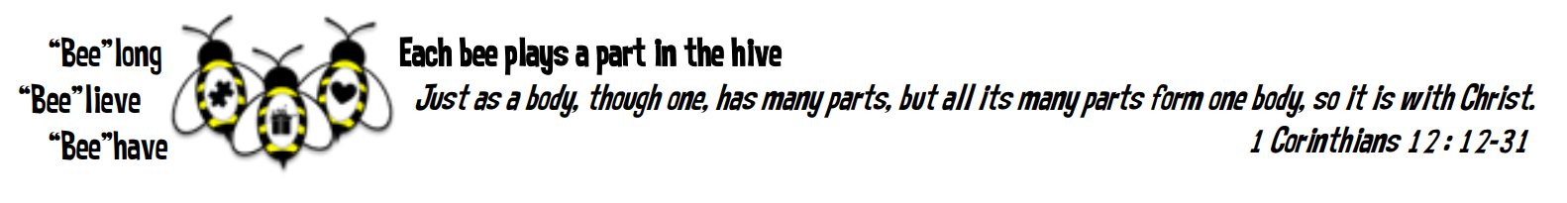

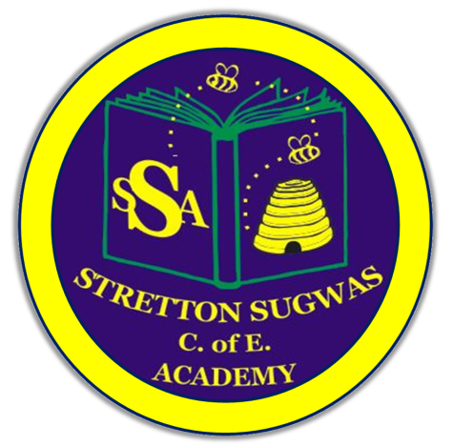

Stretton Sugwas Church of England Academy
Curriculum Overview
Science

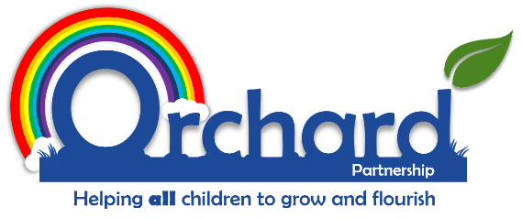
Reviewed: Sep 20025
By: Gemma Cartwright
Introduction: Our Vision
"Each bee plays a part in the hive."
At Stretton Sugwas Church of England Academy, our Christian ethos is rooted in the Body of Christ, reminding us that every individual is valued and has a unique role to play. Our vision—Believe, Behave, Belong—is at the heart of our science curriculum. Through science, we nurture curiosity, encourage children to believe in their abilities as scientists, and guide them to behave in ways that positively impact their community and the wider world.

Intent: Driven By Our Christian Vision
Our science curriculum is designed to help every child discover their inner scientist and foster a lifelong love of enquiry and discovery. We aim to develop confident investigators, critical thinkers, and responsible citizens who appreciate the wonder of the natural world and understand their role in caring for it. By engaging with science, children build essential skills such as teamwork, leadership, creativity, and problem-solving—skills that help them flourish both within and beyond the classroom.
We believe that science is for everyone. Our curriculum is inclusive, ensuring that all children, including those with SEND and other specific needs, can access, enjoy, and achieve in science. Every child is encouraged to ask questions, work collaboratively, and use their scientific understanding to make a positive difference. This approach reflects our commitment to Stretton’s vision: everyone belongs, everyone can believe in their potential, and everyone can behave in ways that enrich our community and protect our planet.

Implementation: Belong, Believe, Behave
Our curriculum is structured around the principles of Belong, Believe, Behave:
- Belong: Children develop the skills to work as effective team members, building relationships and unlocking their scientific potential.
- Believe: Pupils gain subject-specific knowledge and skills, growing in confidence as scientists.
- Behave: Learners are given opportunities to apply their scientific skills in meaningful contexts, using science to make a positive impact on their environment and community.
We follow a spiral curriculum model (Developing Experts), where key scientific skills and knowledge are revisited and built upon over time. Lessons are practical and hands-on, combining enquiry, investigation, observation, and critical thinking. Children explore science from different perspectives, developing respect and appreciation for the diversity of the natural world.
Our approach includes:
- Chunked units for manageable progression.
- Retrieval activities and retention quizzes to strengthen memory.
- Deliberate practice to refine scientific techniques.
- Modelling, scaffolding, and clear success criteria to support all learners.
- Differentiated guidance to ensure accessibility and challenge for every pupil.
Science is timetabled to ensure regular, high-quality experiences for all children. Staff are supported with resources, CPD, and knowledge organisers to deliver engaging lessons. We also provide enrichment opportunities, such as science weeks, workshops, and extra-curricular activities, to raise the profile of science and celebrate children’s achievements.

Impact: Belong, Believe, Behave In Action
We assess the impact of our science curriculum through a range of formative and summative strategies, including observation, practical investigations, pupil voice, and knowledge organisers. Assessment for learning (AfL) is embedded in every lesson, enabling teachers to identify strengths, address gaps, and celebrate progress.
By the end of primary school, our pupils will:
- Be confident investigators, able to ask questions, plan and carry out enquiries, and draw conclusions.
- Show appreciation and respect for the natural world and the role of science in society.
- Understand how science is influenced by cultural, social, and historical contexts.
- Demonstrate enthusiasm for science and identify their own scientific interests.
- Meet the expectations of the National Curriculum for Science.
These outcomes support Stretton’s vision, ensuring that children belong to a scientific community, believe in their abilities, and behave as responsible, curious citizens.

EYFS Links
Science in the Early Years Foundation Stage (EYFS) is closely linked to Understanding the World and Communication & Language. Through exploration, observation, and discussion, children develop curiosity, critical thinking, and self-expression. Science also supports language development, social interaction, and emotional well-being, laying the foundation for lifelong learning and belonging.

Inclusion: SEND And Helping All Learners To Achieve In Science
Our science curriculum is fully inclusive, reflecting our Christian vision that every child should belong, believe, and behave. We ensure that all pupils, including those with SEND and the lowest 20% of learners, can access and succeed in science through high-quality teaching, differentiation, and targeted support.
Adaptations may include:
- Alternative tasks and objectives
- Varied resources and learning aids
- Flexible grouping and peer support
- Personalised feedback and monitoring
- Targeted interventions and enrichment activities
We celebrate every child’s achievements and provide opportunities for all to participate, investigate, and progress in science. Regular monitoring, pupil voice, and collaboration with families and external agencies ensure that our provision meets the needs of every learner.

Other Pupil Groups: More Able and Talented (MAT) and the Highest 20% of Learners
We recognise and nurture the individual gifts and talents of all children. More able and talented pupils are provided with additional challenge and opportunities to extend their scientific skills, ensuring they belong within the scientific community, believe in their abilities, and behave as leaders and role models.
We monitor the progress of all groups, including those with specific needs or circumstances, and adapt our provision to ensure equity and excellence for every learner.

Vocabulary Development
Developing scientific vocabulary is a key part of our curriculum. Children are introduced to and regularly use subject-specific language—such as hypothesis, observation, variable, and conclusion—enabling them to describe, discuss, and evaluate scientific ideas with increasing confidence. Through practical activities and discussion, pupils encounter new words in context, supporting both their scientific understanding and wider literacy. Repetition, discussion, and the use of visual aids help embed vocabulary, while investigations and experiments reinforce language patterns and conceptual understanding.

Technology in Science
Technology is integrated throughout our science curriculum to enhance learning, enquiry, and accessibility. Pupils use digital tools and apps to record data, research information, and present findings. Technology enables children to experiment, collaborate, and access a wide range of scientific resources. We use tablets, and data-logging equipment to support both classroom and independent learning, ensuring that all pupils—including those with SEND—can participate fully. By embracing technology, we prepare children for a digital world and encourage them to believe in their ability to investigate and communicate science in diverse formats.

Local and Cultural Links
Our science curriculum is enriched by strong links to the local community and Herefordshire’s unique environment. We work in partnership with local organisations, environmental groups, and STEM ambassadors to provide pupils with opportunities to participate in workshops, fieldwork, and community projects. Children experience real-world science, meet local experts, and learn about the county’s scientific heritage, fostering pride in their community and a sense of belonging. We celebrate the diversity of science in Herefordshire and beyond, ensuring that all pupils can see themselves reflected in the curriculum and are inspired to contribute to the scientific life of their school and locality.

Monitoring and Review
The effectiveness of our science curriculum is continually monitored and reviewed to ensure high standards and meaningful outcomes for all pupils. We use a range of assessment strategies—including observation, practical investigations, pupil voice, and knowledge organisers—to track progress and inform planning. Regular curriculum reviews, staff training, and collaboration with local partners help us to reflect on and improve our provision. Feedback from children, parents, and staff is valued and used to shape future developments. By maintaining a culture of continuous improvement, we ensure that our science curriculum remains inclusive, ambitious, and aligned with Stretton’s vision of Believe, Behave, Belong.

