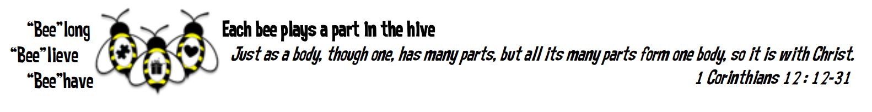
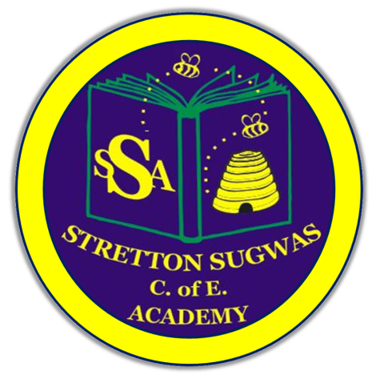

Stretton Sugwas Church of England Academy
Curriculum Overview
PE

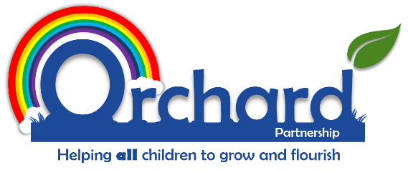

Reviewed: September 2025
L Cuss

Introduction: Our Vision

“Each bee plays a part in the hive.”

At Stretton Sugwas Church of England Academy, our vision—believe, belong, behave—is at the heart of our PE curriculum. We believe PE is a vital subject for developing pupils’ confidence, sense of community, and positive behaviour. Through PE, every child is encouraged to believe in their abilities, belong to a team, and behave with respect, resilience, and sportsmanship. Our spiral curriculum ensures all children, regardless of background or ability, are included, valued, and empowered to flourish physically, socially, and emotionally.

Intent: Driven By Our Christian Vision

Our PE curriculum is designed to:
- Believe: Inspire all pupils to believe in themselves, develop physical confidence, and understand the value of perseverance and self-improvement.
- Belong: Foster a sense of belonging through teamwork, collaboration, and participation in a wide range of physical activities, including local fixtures and showcases that connect pupils to the Hereford community.
- Behave: Promote positive behaviour, fair play, and respect for others, both in lessons and in wider sporting contexts.
We follow a spiral curriculum structure (Get Set 4 PE), ensuring progression and revisiting of key skills and knowledge each year. This approach allows children to build on prior learning, deepen understanding, and achieve their personal best.

Implementation: Belong, Believe, Behave

- Belong: Pupils develop teamwork, leadership, and communication skills through group games, sports, and collaborative challenges. Fixtures and events with local schools help children feel part of the wider Hereford sporting community.
- Believe: High-quality PE lessons teach fundamental movement skills, sport-specific techniques, and healthy lifestyle choices. Learning is step by step, scaffolded where necessary, and knowledge is revisited regularly to ensure retention and progression.
- Behave: Children are given opportunities to apply their skills in real contexts—such as competitions, performances, and community events—demonstrating sportsmanship, resilience, and respect.

How Children Learn in PE

Learning in PE is step by step and carefully scaffolded. Skills are broken down and modelled, with opportunities for practice and feedback. Lessons are structured to revisit and consolidate previous learning, ensuring progression for all. Peer support and differentiated tasks enable every child to access and enjoy PE.

EYFS Links

In the EYFS, PE is closely linked to the Physical Development area of learning. Children develop gross and fine motor skills, coordination, balance, and spatial awareness through structured play, movement activities, and outdoor learning. The foundations laid in EYFS are built upon in KS1 and KS2, ensuring a smooth transition and progression.

Inclusion and SEND

Our PE curriculum is fully inclusive.
Differentiation includes:

- Adaptations to tasks, games, and equipment
- Alterations to races and activities to meet individual needs
- Use of peer support and adult guidance
- Flexible grouping and targeted interventions

We ensure all children, including those with SEND and the lowest 20%, can participate, achieve, and feel valued in PE. Pupil voice and regular monitoring ensure adaptations are effective and meaningful.

More Able/Highest 20%

Pupils identified as more able or in the highest 20% are provided with higher-level challenges and extension activities. This may include advanced skills, leadership roles, representing the school in competitions, and opportunities to mentor peers.

Vocabulary Development

PE-specific vocabulary is explicitly taught and rehearsed through discussion, modelling, and practical activities. Key terms are displayed, referred to in lessons, and revisited regularly to ensure understanding and confident use.

Technology in PE

Technology enhances PE by:
- Using video analysis for skill development and self-assessment
- Accessing online resources and demonstrations
- Recording performances for reflection and improvement
- Supporting inclusion through adapted resources and communication tools

Cultural Links to Hereford

Our PE curriculum celebrates local culture by:
- Participating in Hereford-wide sporting fixtures and festivals
- Showcasing pupils’ achievements in school and community events
- Inviting local sports clubs and athletes to inspire and engage children

Subject Leader Monitoring

The PE subject leader monitors impact through:
- Photographic and video evidence of lessons and events
- Pupil voice interviews to gather feedback and inform improvements
- Reports to governors on curriculum delivery, inclusion, and outcomes

The methods mentioned for how children can learn, develop and be catered for in this subject area are not exhaustive. We are a listening school and are constantly reflecting on feedback from adults and children, with the constant goal of helping all learners to belong, believe and behave.

