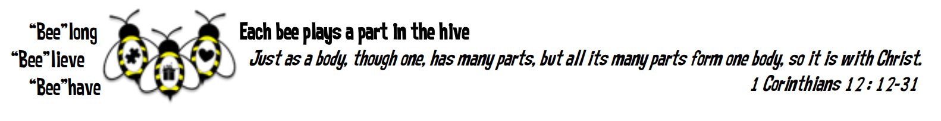
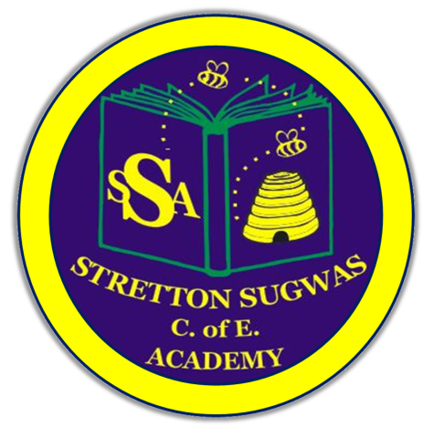

Stretton Sugwas Church of England Academy
Curriculum Overview
History

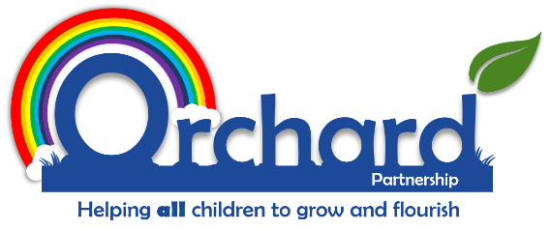

Reviewed: Autumn 2025
Sarah Jones

Introduction: Our Vision

“Each bee plays a part in the hive.”

At Stretton Sugwas CE Academy, our Christian ethos is built upon the theme of the Body of Christ, which teaches us that we are all an important part of a team, have a unique role to play and must work together to help others. As a result, we encourage everyone in the school community to belong to a team, believe in themselves and behave in a compassionate way.

Intent: Driven By Our Christian Vision

History at Stretton Sugwas aims to inspire pupils to be curious and creative thinkers who develop a deep knowledge of local, national and global history. Pupils will be encouraged to think critically, ask questions, analyse historical evidence, and understand the complexity of people’s lives.
Our curriculum intent is to:
- Develop chronological understanding so pupils can build a mental timeline of history.
- Foster an appreciation of how Britain has been shaped by, and has shaped, the wider world.
- Explore the diversity of societies, civilisations and beliefs across time.
- Provide opportunities for pupils to investigate and interpret evidence, developing empathy and critical thinking.
- Prepare pupils for future learning by introducing them to substantive concepts such as power, invasion, settlement and migration, empire, civilisation, religion, trade, and achievements of humankind.
It is integral to our vision that pupils with SEND and other specific needs are supported to access the History curriculum and achieve their full potential.

Implementation: Belong, Believe, Behave

History is taught through enquiry-based questions using the Kapow Primary scheme, which follows a spiral curriculum model. Key concepts and skills are revisited across year groups in new contexts, helping pupils to build secure understanding over time.
Lessons are structured to support how children learn best:
- Chunking of knowledge into small steps to aid understanding.
- Spiral sequencing, revisiting key knowledge and concepts across year groups.
- Retrieval activities and knowledge quizzes to strengthen memory.
- Oracy and discussion through debates, hot-seating, and structured speaking tasks.
- Use of disciplinary skills (cause & consequence, continuity & change, significance, interpretation, use of sources).
- Knowledge organisers and timelines to support recall and connections.

Cross-curricular links are highlighted in planning to deepen learning, including English (reading/writing), Art (artefact sketching), Geography (maps/locations) and Computing (digital research and presentations).
Technology in History
Pupils use technology to research evidence, explore online archives and census data, present projects digitally, and access interactive timelines and maps.
Local and Cultural Context
History is brought to life through local studies, linking the curriculum to Herefordshire’s heritage. Pupils will explore:
- The impact of the Hereford Cattle trade.
- The role of Herefordshire during the Civil War and World War II.
- Visits to local sites such as Hereford Cathedral, Black & White House Museum, and Hereford Archive & Records Centre.
- Work with Herefordshire Heritage Services and local historians.

Impact: Belong, Believe, Behave in Action

Pupils will leave Stretton Sugwas with a strong historical foundation, enabling them to succeed in secondary education. They will:
- Demonstrate secure chronological understanding and the ability to make connections across periods of history.
- Apply disciplinary skills to form historical arguments and balanced judgements.
- Use subject-specific vocabulary (Tier 2 and Tier 3) confidently in both written and spoken work.
- Show curiosity and empathy, understanding how the past shapes the present.
Impact will be assessed through:
- Lesson observations and learning walks.
- Pupil voice and discussions.
- Book looks and moderation (using Pollen8 where appropriate).
- End-of-unit quizzes and knowledge checks.
- Termly Arbor data submissions.

EYFS
In EYFS, History is introduced through Understanding the World. Children learn about their own lives and families, compare past and present, and explore how things change over time. Activities include:
- Personal timelines.
- Family trees.
- Comparing old and new toys, photos and objects.
- Exploring stories about people in the past.
These foundations prepare pupils for KS1 by introducing chronology, evidence, and similarities/differences.

Vocabulary Development
Pupils are explicitly taught Tier 2 (analytical) and Tier 3 (subject-specific) vocabulary. Vocabulary is reinforced through:
- Knowledge organisers.
- Sentence stems for discussions.
- Word walls and displays.
- Structured debates and critiques.

Inclusion: SEND and Helping All Learners
Every teacher is a teacher of SEND and every leader is a leader of SEND. Differentiation in History may include:
- Alternative tasks or adapted success criteria.
- Scaffolding with visuals, timelines or graphic organisers.
- Targeted adult/peer support.
- Extra time and adapted resources.
Further support may involve small group interventions, pre-teaching of vocabulary, enrichment visits tailored to needs, or pupil progress meetings to identify barriers and strategies.

More Able and Talented Learners
More able pupils are challenged through:
- Higher-order questioning and enquiry tasks.
- Opportunities for independent projects.
- Deeper analysis of sources and interpretations.
- Leadership roles in debates and group tasks.
Monitoring ensures more able pupils are consistently stretched and able to demonstrate deeper thinking.

Monitoring and Review
The History subject leader is responsible for:
- Monitoring coverage, progression, and quality of teaching.
- Reviewing planning, pupil work, and assessment data.
- Collecting pupil voice to evaluate engagement and challenge.
- Reporting termly to SLT and governors.
This policy will be reviewed annually to ensure alignment with the SDP and national guidance.

