
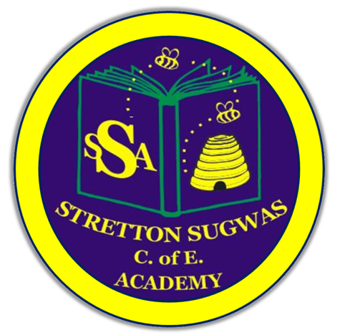

Stretton Sugwas Church of England Academy
Curriculum Overview
Languages

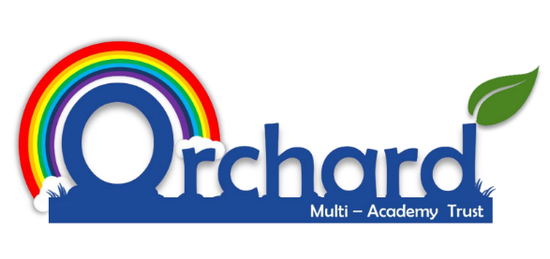

Reviewed: Autumn 2025
Mr Ford and The Global Gang

Introduction: Our Vision

“Each bee plays a part in the hive.”

At Stretton Sugwas Church of England Academy, our Christian ethos is built upon the theme of the Body of Christ, which teaches us that we are all an important part of a team, have a unique role to play and must work together to help others. As a result, we encourage everyone in the school community to belong to a team, believe in themselves and behave in a compassionate way.

Intent: Driven By Our Christian Vision

We believe that our vision should also be reflected throughout our Languages curriculum, as well as being the principle foundation on which our curriculum is built. The Body of Christ passage from the Bible explains that we all have an interdependent and equally valuable role to play in achieving great things together to help others and make a difference. This is what underpins the way in which we have organised our curriculum and monitor its effectiveness.

Our Languages curriculum should build upon the Areas of Learning and Development that are explored through the Early Years Foundation Stage (EYFS), allowing all pupils at Stretton Sugwas the opportunity to be included, feel appreciated and develop their voice from an early age. It should allow opportunities to work as part of a team and appreciate their role as well as the role of others. Children will gain new skills and knowledge but the challenge of our curriculum is to then put them into practice to use them to make a positive impact, in whatever creative way they imagine.

It is integral to our vision that pupils with SEN and other specific needs are given support to access the curriculum, develop their talents and use them to make an impact appropriate to their needs. Everyone is valued and has a role to play. If our curriculum, policies or practices are not fully inclusive then we will adapt them. Informal feedback from pupils, staff and parents as well as more formal reviews and monitoring will help the school to reflect on what it does to cater for all pupils’ needs, in accordance with its vision.

Implementation: Belong, Believe, Behave

In accordance with our Christian vision, we have structured our curriculum documents into three sections:

- Belong- the skills needed to work as an effective team member and begin to unlock their potential in the relevant subject area (coded in yellow).
- Believe- the subject-specific knowledge and skills needed to develop talents (coded in green).
- Behave- the skills and opportunities needed to apply the subject-specific skills in a meaningful context (coded in blue).

As well as providing as overview of the units covered within the schemes of learning we use, our 3 Bees Framework for Flourishing, which is based on the content of the National Curriculum, also includes the following additional headings and skills into a coherently aligned map (see picture below):

- British Values*
- Christian Values*
- Oracy and Pupil Voice
- Inclusion
- Creativity
- Personal Development and Enrichment
- Deeper Questions and Spirituality (*Refer to SMSC document)
- Global Citizenship
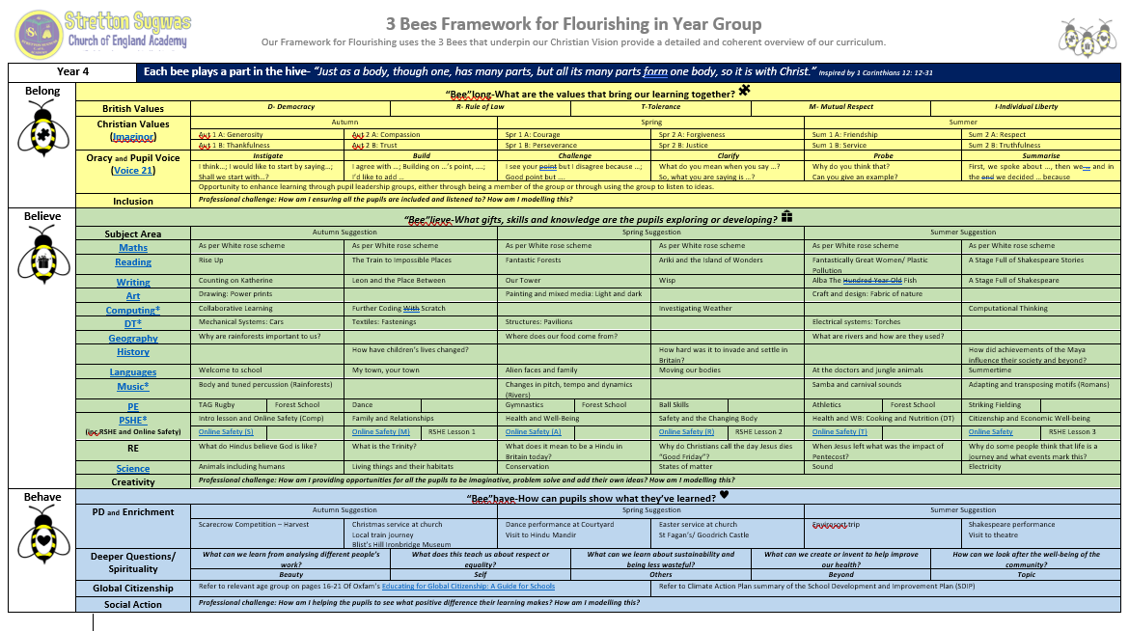
- Social Action

We have deliberately done this to make more explicit and embed the necessary skills we believe are essential in helping pupils to apply what they learn in order to help others and make a positive difference in their communities and wider world- which reiterates our Christian vision.
Implementing How Children Learn in Languages
We recognise that children learn best when prior knowledge is built upon and learning is revisited in small steps. To support this:
- We use Primary Language Network curriculum, which follows a spiral model, revisiting key skills and knowledge over time to embed learning.
- Units are chunked into manageable sequences, ensuring progression and secure understanding.
- Retrieval activities and retention quizzes are built in to support memory and help pupils to revisit and strengthen prior knowledge.
- Opportunities for deliberate practice allow pupils to refine techniques over time.
- Lessons are designed with modelling, scaffolding and clear success criteria, enabling pupils to see what high-quality outcomes look like.
This approach ensures that all pupils are supported in remembering and applying their learning, while also being challenged to take risks and develop independence.

Implementing Vocabulary Development in Languages

Languages provides rich opportunities for developing both Tier 2 (general academic) and Tier 3 (subject-specific) vocabulary. Pupils are explicitly taught key words related to the learning of language, the culture as well as the target language vocabulary itself. Oracy is developed through:
- Structured discussions about language learning
- Use of sentence stems to build confidence in using the target language
- Playing with language and having fun.
This ensures pupils can articulate their learning and use subject language accurately.

Impact: Belong, Believe, Behave In Action

Crucial to our Christian Vision and educational provision at Stretton Sugwas is the fact that skills and knowledge must be applied within a real-life context. We believe that pupils should be taught how to use their skills to impact the environment around them, wherever realistically possible. Children should be given opportunities to explore the relevance of the skills they are being taught so that it may inspire them.

Assessing the impact of the teaching of the curriculum on pupil learning may take many forms and may be supported by one or more of the following strategies:

- Observing children’s work, individually, in pairs, in groups and in class during whole class teaching.
- Recording of the progress made by children against the learning objectives for each lesson with agreed success criteria.
- Using differentiated, open-ended questions that require children to explain and deepen their understanding.
- Providing effective feedback, both written and verbal, to engage children with their learning and to provide opportunities for self-assessment, consolidation and target setting.
- Book moderation and monitoring of outcomes of work, to evaluate the range and balance of work and to ensure that tasks meet the needs of different learners.
- Encouraging children to assess and evaluate both their own work and that of other pupils to appreciate how they can improve their performance and set their targets for the future.
- Formally reporting each child’s attainment and progress to parents at the end of the year in the child’s end of year report.
- Document analysis, pupil interviews, book trawls and lesson observations from subject leaders.
- Quizzes and meaningful activities for children to celebrate and showcase their learning.
- Parental questionnaires.

This is a working document and practitioners may change or adapt specific skills or ideas based on helping increase the ways that children engage with their learning, helping them to see where they belong, believe in their skills and behave in a way that uses their learning to impact the world around them.

The Impact of Local and Cultural Curriculum Links

In line with the “behave” part of our Christian Vision and Curriculum Overview document, we see the importance of Personal Development (PD) and Enrichment opportunities in providing children with real-life local and cultural links within their learning. We believe that such links help children to see first-hand how their learning is “lived-out” and how this may be used to deepen their understanding, see learning beyond the classroom and, ultimately, how this may be used to make a difference to themselves and others.

The Languages curriculum at Stretton Sugwas draws on local and global links to enhance learning. Pupils engage with:
- Other local schools to practice language patterns
- Partnerschools from around the world to practice language skills and develop cultural awareness
- Parents/carers and other community members to showcase their learning.
This provides children with a sense of pride, belonging and awareness of the cultural richness of their world.

Monitoring and Reviewing the Impact of Learning

The success of the curriculum and its impact is monitored regularly by the subject lead(s) and the pupils, which includes the specific Language-focused group of The Global Gang.

Leads work closely with colleagues within Stretton Sugwas Church of England Academy and across other schools to keep up-to-date with current research and thinking within the subject in order to positively impact pupil learning.

The Language subject leader is responsible for:
- Monitoring the quality of teaching and learning through book looks, lesson visits, and pupil voice
- Tracking coverage and progression across year groups
- Reviewing and updating curriculum documentation annually
- Reporting to senior leaders and governors on standards and developments in Languages.
This policy will also be reviewed regularly to ensure it continues to reflect the school’s Christian vision and commitment to inclusion.

Inclusion: SEND And Helping All Learners To Achieve In Languages

Our Christian vision challenges all subject leaders to reflect on ensuring that the Languages curriculum helps all pupils to belong and access learning, appropriate to their needs and abilities. Inclusion and belonging is a thread that runs through every area of the school enhanced by collaboration between senior leaders, subject leaders, the SENCO, class teachers, support staff, external agencies, parents and most importantly, the child. At Stretton Sugwas Church of England Academy, every teacher is a teacher of SEND and every leader is a leader of SEND.

Special Educational Needs and Disability (SEND)- Including the Lowest 20% of Learners

We firmly believe that Quality First Teaching is the solid foundation on which effective SEND provision is built. The first step to children having access to a broad and balanced Languages curriculum is through appropriate differentiation by skilled and nurturing teaching staff, who have ambitious expectations of their own teaching and students’ learning. Differentiation is not a simply case of providing different worksheets, for example. Differentiation is adapting the work, success criteria or support given to help children achieve or make progress.

Differentiation- or adaptations- may include:

- Alternative tasks
- Different objectives or goals within a task
- Resources or learning aids
- Amount of adult support within a task
- Frequency of monitoring within a session
- Time given to complete tasks
- Style of language used
- Style of questioning used
- Use of peer support
- Classroom organisation and grouping
- Level or style of feedback given

Differentiation takes many forms to help learners to belong within lessons, believe in their ability and behave in a way that applies their skills. Further support to help inclusion and overall pupil progress in this subject area may include:

- Targeted intervention programmes, which have a proven and measurable impact on progress.
- Have specific 1:1 or small group intervention, including support from Learning Mentor
- Celebration of achievement, as well as attainment
- Time given, as appropriate, to any emotional or behavioral support that may-in turn- be barriers to learning in this subject area
- Monitor pupil attitudes to subject and using pupil voice to ensure that learners have ownership of subject area/tasks
- Specific enrichment activities, visits or events planned/attended in order to suit the needs and interests of specific groups of learners
- Pupil progress meetings, involving the pupil(s) and any relevant adults
- Data analysis, whether this is quantitative performance data from tests, for example, or qualitative data from questionnaires or monitoring observations
- The provision of good quality and relevant training for all staff members.

Other Pupil Groups- Including More Able and Talented (MAT) and Highest 20% of Learners

We believe that all children have individual gifts, interests and talents. Some children may exhibit a skill that is advanced in comparison to their peers. As a result, such pupils will require a higher level of challenge in order for them to belong, be included within Languages sessions and have their needs met. More able and talented pupils (MAT) will also receive differentiation and support appropriate to their needs.

Adapting tasks and providing opportunities to help all children to achieve well will also depend on the diversity of the groups of learners that are represented at Stretton Sugwas Church of England Academy.

Groupings of learners that could identify trends, spikes or dips in overall progress may include:

- Forces children
- Gender
- Behavioral needs
- Children with emotional needs
- EAL children
- Age (i.e summer born)
- Attendance
- Family support
- LAC
- Ethnicity
- Those experiencing tragedy or loss
- Low self-esteem

This list is not exhaustive and neither are the methods mentioned in how learners can be catered for in this subject area. We are a listening school and are constantly reflecting on feedback from adults and children, with the constant goal of helping all learners to belong, believe and behave.

Including Early Years Foundation Stage (EYFS)

In EYFS, Languages is developed primarily through Communication & Language and Physical Development, with strong links to Knowledge and Understanding of the World. Children are encouraged to:
- Develop awareness of other cultures and differences
- Explore how to communicate with each other
- Play with sounds and noises.

These foundations prepare pupils for progression into the KS1 English curriculum and our taster lessons in languages, as well as the KS2 Languages curriculum.

Including Pupil Voice

To promote the development of Languages, the pupils promise to:

- Reward pupils for trying their languages around the school
- Set up clubs or opportunities to practise languages
- Work hard with partnerschools to develop language links
- Display languages around the school
- Be welcoming of pupils from around the word
- Be diverse

Innovation and Imagination: Using Technology in Languages

Creativity plays an important role in our curriculum. Children are given time to explore, discuss and play, wherever possible, providing an important step to seeing how their learning can positively impact others in the “belong” section of our Framework for Flourishing document. Technology enhances accessibility and opens up new avenues for linguistic expression. Where appropriate, pupils use technology to support creativity and exploration, including:
- Using videocalling to communicate with partnerschools and/or native speakers
- Recording themselves to appraise work and self-improve
- Playing games that consolidate and enhance their proficiency with a target language.

Complaints or Concerns
Any complaints or concerns regarding Languages at Stretton Sugwas Church of England Academy and the aspects mentioned in this Curriculum Overview can be directed to the Headteacher, or in extreme cases, the Chair of the Local Advocate Board. Details can be found on the school website or by getting in touch with the school office.

We are a listening school.

