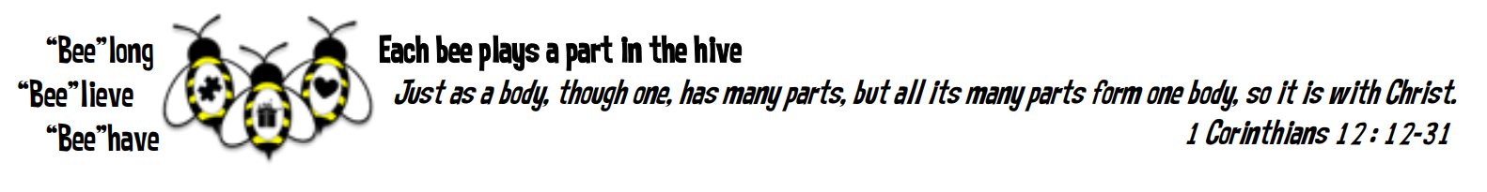
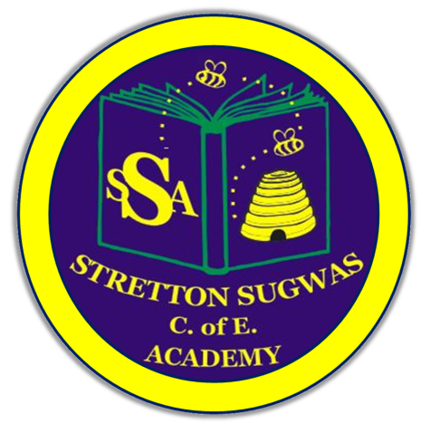

Stretton Sugwas Church of England Academy
Curriculum Overview
Geography

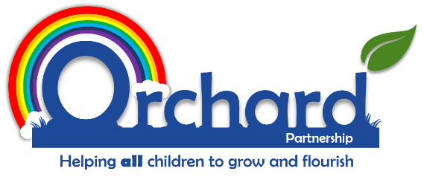

Reviewed: Autumn 2025
Miss Bethan Bowen
Introduction: Our Vision
“Each bee plays a part in the hive.”
At Stretton Sugwas Church of England Academy, our Christian ethos is built upon the theme of the Body of Christ, which teaches us that we are all an important part of a team, have a unique role to play, and must work together to help others. As a result, we encourage everyone in the school community to belong to a team, believe in themselves, and behave in a compassionate way.

Intent: Driven By Our Christian Vision

We believe that our vision should be reflected throughout our curriculum, and Geography is no exception. The Body of Christ passage from the Bible explains that we all have an interdependent and equally valuable role to play in achieving great things together to help others and make a difference. This underpins the way in which we have organised our Geography curriculum and monitor its effectiveness.

Our Geography curriculum allows all children the opportunity to be included, feel appreciated, and develop their voice.

Pupils will gain knowledge of the world, understand how humans and the environment interact, and develop skills to make informed decisions. The challenge of our curriculum is for children to use these skills to positively impact their communities and the wider world.

It is integral that pupils with SEND and other specific needs are supported to access Geography, develop their talents, and use them meaningfully.

Everyone is valued and has a role to play. If our curriculum, policies, or practices are not fully inclusive, we will adapt them. Informal feedback from pupils, staff, and parents, as well as formal reviews and monitoring, will help the school reflect on how well we meet all pupils’ needs in accordance with our vision.

Implementation: Belong, Believe, Behave

Our Geography curriculum is designed to reflect our Christian vision by helping pupils understand the world around them, develop their God-given talents, and apply their learning to make a positive difference in their communities and the wider world.

The curriculum is structured around three key strands:

Belong – Pupils develop the skills needed to work effectively as part of a team and begin to unlock their potential in Geography.
Believe – Pupils acquire subject-specific knowledge and skills to deepen their geographical understanding and nurture their individual talents.
Behave – Pupils are given opportunities to apply their Geography skills meaningfully, ideally impacting others positively and contributing to the common good.

To support this, we provide a Framework for Flourishing Skills Progression, aligned with the National Curriculum and enhanced with additional skills inspired by the OXFAM Education for Global Citizenship guidance.

These skills are explicitly developed throughout the Geography curriculum under the following headings:

- Communication and Pupil Voice – Expressing ideas clearly and contributing meaningfully to discussions.
- Teamwork and Leadership – Collaborating effectively and taking initiative within groups.
- Problem Solving and Critical Thinking – Analysing information and making informed decisions.
- Creativity and Imagination – Developing innovative approaches to geographical questions and projects.
- Social Action and Community Involvement – Applying learning to benefit others locally and globally.
- Global Learning and Sustainability – Understanding interconnections, environmental responsibility, and global citizenship.

These skills ensure that pupils can transfer their geographical learning into real-world contexts, embodying our Christian values of service, stewardship, and compassion.

To make learning tangible and memorable, we have created Termly Curriculum Overviews. These outline when National Curriculum knowledge and skills are taught, using the Belong, Believe, and Behave framework. Cross-curricular links are highlighted to create engaging and meaningful learning experiences, helping pupils see the relevance of Geography to their lives and the wider world.

How Children Learn in Geography

We recognise that children learn best when prior knowledge is built upon and revisited in small steps.

To support this:

- Units are chunked into manageable sequences, ensuring progression and secure understanding.
- Retrieval activities and retention quizzes support memory and help pupils revisit prior knowledge.
- Deliberate practice allows pupils to refine geographical skills over time.
- Lessons include modelling, scaffolding, and clear success criteria, helping pupils see high-quality outcomes.

This approach ensures all pupils can remember, apply, and build upon prior learning while being challenged to take risks and develop independence.

Impact: Belong, Believe, Behave in Action

Crucial to our Christian vision is that Geography skills and knowledge are applied within real-life contexts.

Pupils are taught how Geography affects communities, environments, and global issues, and they are encouraged to use their skills to make a positive difference.
Assessment of impact may include:

- Observing children’s work individually, in pairs, and in groups.
- Recording progress against lesson objectives with agreed success criteria.
- Using differentiated, open-ended questions to deepen understanding.
- Providing effective feedback for self-assessment, consolidation, and target setting.
- Book moderation and monitoring to evaluate outcomes.
- Encouraging children to assess their own work and that of peers.
- Reporting attainment and progress to parents annually.
- Document analysis, pupil interviews, lesson observations, quizzes, and meaningful activities to celebrate learning.
- Parental questionnaires.

This is a working document; practitioners may adapt skills or ideas to increase engagement and help children see where they belong, believe, and behave in Geography.

Inclusion: SEND and Helping All Learners Achieve in Geography

Our Christian vision ensures all pupils can belong and access learning appropriate to their needs. Inclusion runs through every area of school life, supported by collaboration between leaders, teachers, support staff, parents, and pupils.

Adaptive Teaching

At Stretton Sugwas, we recognise that every child learns differently, and that Geography should be accessible and engaging for all pupils. Our teaching is adapted to meet a wide range of needs, ensuring that every child can participate fully and achieve their potential.

Adaptations include:

- Differentiated tasks to provide appropriate challenge for all abilities, from scaffolded support to extension activities.
- Varied learning approaches, including visual, auditory, and kinaesthetic activities, to cater to different learning styles.
- Use of technology and resources, such as digital mapping tools, interactive maps, and virtual field trips, to enhance understanding and engagement.
- Targeted support for pupils with additional needs, including personalised resources, small-group teaching, and one-to-one guidance where required.
- Encouragement of pupil voice to allow children to express their understanding in multiple ways, fostering confidence and independence.

By adapting our teaching, we ensure that all pupils can develop geographical knowledge and skills, apply them meaningfully in real-world contexts, and experience the sense of achievement, belonging, and stewardship central to our Christian vision.

SEND – Including the Lowest 20% of Learners
Quality First Teaching is the foundation of effective SEND provision. Differentiation is key, adapting work, success criteria, or support to help children achieve or make progress.

Differentiation Strategies may include:

- Alternative tasks or objectives
- Resources or learning aids
- Varying adult support
- Adjusted timing for tasks
- Language, questioning, or grouping adaptations
- Style and level of feedback

Further support may include targeted interventions, small-group support, emotional or behavioural assistance, enrichment activities, pupil progress meetings, and staff training.

Other Pupil Groups – Including More Able and Talented (MAT) and the Highest 20% of Learners
All children have individual gifts and talents. More able pupils in Geography may require higher-level challenge and differentiation to ensure their needs are met.

- Grouping may also consider:
- Forces children
- Gender
- Behavioural or emotional needs
- EAL children
- Age
- Attendance
- Family support
- LAC
- Ethnicity
- Those experiencing tragedy or loss
- Low self-esteem

Early Years Foundation Stage (EYFS)

In EYFS, Geography is developed primarily through Understanding the World, with strong links to Communication & Language and Physical Development. Children are encouraged to:

- Explore their local environment and the wider world.
- Develop curiosity, observation skills, and the ability to ask questions about places, people, and natural features.
- Use simple maps, globes, and images to identify familiar locations.
- Talk about their observations and experiences, developing vocabulary and confidence in communication.

These foundations prepare pupils for progression into the KS1 Geography curriculum.

Vocabulary Development

Geography provides rich opportunities for developing both Tier 2 (general academic) and Tier 3 (subject-specific) vocabulary. Pupils are explicitly taught key words related to places, environments, geographical processes, and fieldwork. Oracy is developed through:

- Structured discussions and exploration of maps, photographs, and geographical data.
- Use of sentence stems to build confidence in speaking about locations, features, and processes.
- Labelling, annotation, and reflective writing about observations and findings.
- This ensures pupils can articulate their learning and use subject language accurately.

Technology in Geography

Where appropriate, pupils use technology to support exploration and understanding, including:

- Digital mapping platforms and GIS tools.
- Photography, video, and data collection for fieldwork.
- Researching geographical features, countries, and cultures.
- Recording and presenting their own work digitally.
- Technology enhances accessibility and opens up new avenues for learning about the world.

Local and Cultural Context / Fieldwork

The Geography curriculum at Stretton Sugwas draws on the local environment and cultural heritage of Herefordshire, giving pupils opportunities to explore and engage with the world around them.

Pupils experience:

- Local landmarks and natural features, such as the River Wye, Malvern Hills, Hereford Cathedral, and surrounding woodlands and farms.
- Fieldwork in the local area to investigate human and physical geography, including mapping the school grounds, surveying local parks, and observing land use in the village.
- Visits to geographical and cultural sites, such as Hereford Museum and Art Gallery, the Herefordshire countryside, and nearby nature reserves.
- Investigation of local environmental and community issues, including river pollution, recycling initiatives, and wildlife conservation projects.

These experiences help pupils develop practical geographical skills, foster a sense of pride and belonging, and deepen their understanding of the cultural and natural richness of their locality, while making connections to wider global contexts.

Monitoring and Review

The Geography subject leader is responsible for:

- Monitoring the quality of teaching and learning through book looks, lesson visits, and pupil voice.
- Tracking coverage and progression across year groups.
- Reviewing and updating curriculum documentation annually.
- Reporting to senior leaders and governors on standards and developments in Geography.

This policy will be reviewed regularly to ensure it continues to reflect the school’s Christian vision and commitment to inclusion.

