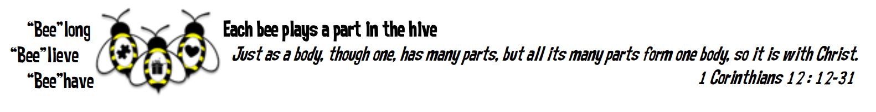

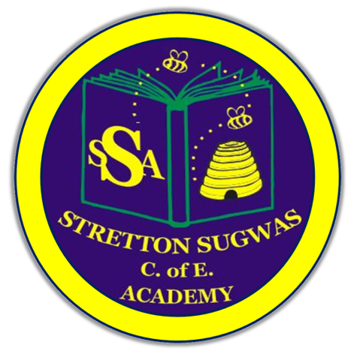

Stretton Sugwas Church of England Academy
Curriculum Overview
Music

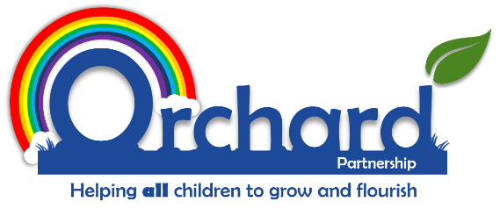
Reviewed: Sep 2025
By: Gemma Cartwright
Introduction: Our Vision
"Each bee plays a part in the hive."
At Stretton Sugwas Church of England Academy, our Christian ethos is rooted in the Body of Christ, reminding us that every individual is valued and has a unique role to play. Our vision—Believe, Behave, Belong—is at the heart of our music curriculum. Through music, we nurture a sense of belonging, encourage children to believe in their abilities, and guide them to behave in ways that positively impact their community.

Intent: Driven By Our Christian Vision
Our music curriculum is designed to help every child discover that they are musical and to foster a lifelong love of music. We aim to develop confident performers, composers, and listeners who appreciate music from a wide range of cultures and traditions. By engaging with music, children build essential skills such as teamwork, leadership, creativity, and critical thinking—skills that help them flourish both within and beyond the classroom.
We believe that music is for everyone. Our curriculum is inclusive, ensuring that all children, including those with SEND and other specific needs, can access, enjoy, and achieve in music. Every child is encouraged to find their voice, work collaboratively, and use their musical talents to make a positive difference. This approach reflects our commitment to Stretton’s vision: everyone belongs, everyone can believe in their potential, and everyone can behave in ways that enrich our community.

Implementation: Belong, Believe, Behave
Our curriculum is structured around the principles of Belong, Believe, Behave:
- Belong: Children develop the skills to work as effective team members, building relationships and unlocking their musical potential.
- Believe: Pupils gain subject-specific knowledge and skills, growing in confidence as musicians.
- Behave: Learners are given opportunities to apply their musical skills in meaningful contexts, using music to make a positive impact.
We follow a spiral curriculum model (Kapow Primary), where key musical skills and knowledge are revisited and built upon over time. Lessons are practical and hands-on, combining listening, performing, composing, improvising, and understanding notation. Children explore music from different genres, cultures, and historical periods, developing respect and appreciation for diversity.
Our approach includes:
- Chunked units for manageable progression.
- Retrieval activities and retention quizzes to strengthen memory.
- Deliberate practice to refine musical techniques.
- Modelling, scaffolding, and clear success criteria to support all learners.
- Differentiated guidance to ensure accessibility and challenge for every pupil.
Music is timetabled to ensure regular, high-quality experiences for all children. Staff are supported with resources, CPD, and knowledge organisers to deliver engaging lessons. We also provide enrichment opportunities, such as performances, workshops, and extra-curricular activities, to raise the profile of music and celebrate children’s achievements.

Impact: Belong, Believe, Behave In Action
We assess the impact of our music curriculum through a range of formative and summative strategies, including observation, performance, pupil voice, and knowledge organisers. Assessment for learning (AfL) is embedded in every lesson, enabling teachers to identify strengths, address gaps, and celebrate progress.
By the end of primary school, our pupils will:
- Be confident performers, composers, and listeners, able to express themselves musically.
- Show appreciation and respect for a wide range of musical styles and traditions.
- Understand how music is influenced by cultural, social, and historical contexts.
- Demonstrate enthusiasm for music and identify their own musical preferences.
- Meet the expectations of the National Curriculum for Music.
These outcomes support Stretton’s vision, ensuring that children belong to a musical community, believe in their abilities, and behave as responsible, creative citizens.

EYFS Links
Music in the Early Years Foundation Stage (EYFS) is closely linked to Expressive Arts and Design and Communication & Language. Through singing, playing instruments, and moving to music, children develop listening skills, creativity, and self-expression. Music also supports language development, social interaction, and emotional well-being, laying the foundation for lifelong learning and belonging.

Inclusion: SEND And Helping All Learners To Achieve In Music
Our music curriculum is fully inclusive, reflecting our Christian vision that every child should belong, believe, and behave. We ensure that all pupils, including those with SEND and the lowest 20% of learners, can access and succeed in music through high-quality teaching, differentiation, and targeted support.
Adaptations may include:
- Alternative tasks and objectives
- Varied resources and learning aids
- Flexible grouping and peer support
- Personalised feedback and monitoring
- Targeted interventions and enrichment activities
We celebrate every child’s achievements and provide opportunities for all to participate, perform, and progress in music. Regular monitoring, pupil voice, and collaboration with families and external agencies ensure that our provision meets the needs of every learner.

Other Pupil Groups: More Able and Talented (MAT) and the Highest 20% of Learners
We recognise and nurture the individual gifts and talents of all children. More able and talented pupils are provided with additional challenge and opportunities to extend their musical skills, ensuring they belong within the music community, believe in their abilities, and behave as leaders and role models.
We monitor the progress of all groups, including those with specific needs or circumstances, and adapt our provision to ensure equity and excellence for every learner.

Vocabulary Development
Developing musical vocabulary is a key part of our curriculum. Children are introduced to and regularly use subject-specific language—such as rhythm, pitch, tempo, dynamics, and timbre—enabling them to describe, discuss, and evaluate music with increasing confidence. Through singing, listening, and practical activities, pupils encounter new words in context, supporting both their musical understanding and wider literacy. Repetition, discussion, and the use of visual aids help embed vocabulary, while songs and rhymes reinforce language patterns and phonological awareness. This focus on vocabulary ensures that all children, regardless of background, can access and articulate their musical learning, supporting their sense of belonging and achievement.

Technology in Music
Technology is integrated throughout our music curriculum to enhance learning, creativity, and accessibility. Pupils use digital tools and apps to compose, record, and edit music, as well as to explore sound and musical structure. Technology enables children to experiment with music-making in new ways, collaborate with others, and access a wide range of musical genres and resources. We use tablets to support both classroom and independent learning, ensuring that all pupils—including those with SEND—can participate fully. By embracing technology, we prepare children for a digital world and encourage them to believe in their ability to create and share music in diverse formats.

Local and Cultural Links
Our music curriculum is enriched by strong links to the local community and Herefordshire’s vibrant cultural scene. We work in partnership with organisations such as the Herefordshire and Worcestershire Music Hub (Severn Arts, Encore Enterprises), Herefordshire Cultural Partnership, and local arts groups to provide pupils with opportunities to participate in workshops, performances, and festivals. Children experience live music, meet local musicians, and learn about the county’s musical heritage, fostering pride in their community and a sense of belonging. We celebrate the diversity of music in Herefordshire and beyond, ensuring that all pupils can see themselves reflected in the curriculum and are inspired to contribute to the cultural life of their school and locality.

Monitoring and Review
The effectiveness of our music curriculum is continually monitored and reviewed to ensure high standards and meaningful outcomes for all pupils. We use a range of assessment strategies—including observation, performance, pupil voice, and knowledge organisers—to track progress and inform planning. Regular curriculum reviews, staff training, and collaboration with local partners help us to reflect on and improve our provision. Feedback from children, parents, and staff is valued and used to shape future developments. By maintaining a culture of continuous improvement, we ensure that our music curriculum remains inclusive, ambitious, and aligned with Stretton’s vision of Believe, Behave, Belong.

