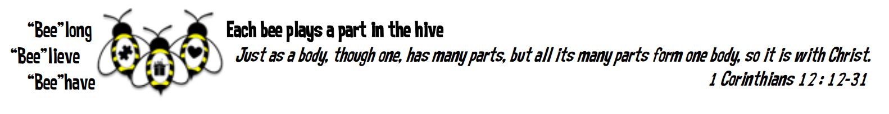
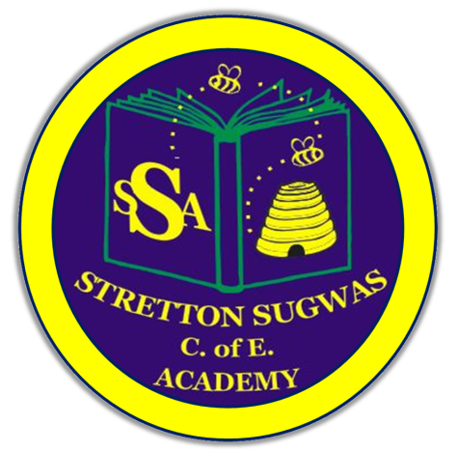

Stretton Sugwas Church of England Academy
Curriculum Overview
DT

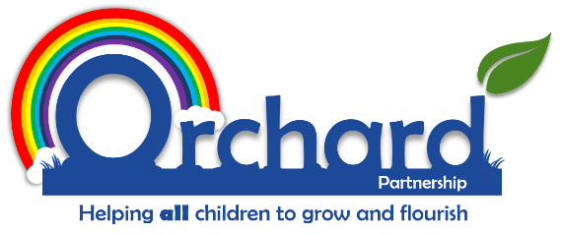

Reviewed: Autumn 2025
Ashleigh Bartle

Introduction: Our Vision
“Each bee plays a part in the hive.”
Our DT curriculum is built on our Christian ethos, where every child is valued, included, and empowered to belong to a team, believe in themselves, and behave compassionately. This vision underpins all curriculum decisions, ensuring every pupil can access, enjoy, and achieve in Design and Technology.

Intent: Driven By Our Christian Vision
Our DT curriculum is designed to:
- Belong: Foster teamwork, communication, and a sense of community, ensuring all children feel included and valued.
- Believe: Build subject-specific knowledge and skills, enabling pupils to develop confidence and resilience as designers, makers, and evaluators.
- Behave: Encourage children to apply their learning in meaningful contexts, making a positive impact on their school, local community, and wider world.
Spiral Curriculum Structure:
The curriculum follows the Kapow spiral model, ensuring that key concepts and skills are revisited and deepened each year. Progression is mapped across all strands (structures, mechanisms, textiles, electrical systems, digital world, and cooking & nutrition), with clear knowledge and skills statements for each year group. This approach supports retrieval, long-term retention, and secure progression from EYFS to Year 6.
Vocabulary Development:
- Tier 2 vocabulary (high-frequency words used across subjects, e.g., evaluate, analyse, criteria, process) and Tier 3 vocabulary (subject-specific terms, e.g., mechanism, pneumatic) are explicitly taught, modelled, and rehearsed in every unit.
- Vocabulary is introduced at the start of each topic, displayed in classrooms, and revisited through discussion, critique, and practical activities.
- Oracy is developed through Voice 21 strategies, ensuring all children can confidently articulate their ideas using precise and accurate language.
How Children Learn:
Learning is carefully chunked and scaffolded.
- Lessons are broken into manageable steps, with explicit modelling and guided practice.
- Retrieval practice is embedded through regular quizzes, discussion, and revisiting of prior learning.
- Pre-teaching and scaffolding are used to prevent cognitive overload, ensuring all children can access and retain new knowledge.
- The spiral curriculum ensures that concepts and vocabulary are revisited in different contexts, deepening understanding and supporting all learners.
EYFS Links:
In EYFS, DT is rooted in hands-on exploration, play, and purposeful making. Children develop fine motor skills, experiment with materials, and begin to plan, make, and evaluate simple products (e.g., junk modelling, boats, food preparation). These experiences lay the foundation for progression into KS1 and beyond.

Implementation: Belong, Believe, Behave
Belong:
- Children work collaboratively, sharing ideas, giving feedback, and supporting each other.
- Communication and teamwork are explicitly taught and valued.
- All children are encouraged to contribute, ensuring every voice is heard.
Believe:
- The curriculum is sequenced to build knowledge and skills progressively, with clear end points for each unit and year group.
- Vocabulary is a key focus:
  - Tier 2 and Tier 3 words are embedded in lesson plans, displays, and assessment.
  - Children are encouraged to use technical vocabulary in their speaking and writing, supporting deeper understanding and retention.
- Oracy is developed through Voice 21 strategies, with children encouraged to articulate their thinking and reflect on their learning.
Behave:
- Pupils are given opportunities to apply their skills in real-life contexts, such as designing for a purpose, solving problems, and evaluating the impact of their work.
- Technology is used to enhance learning and research.
- Cultural links are made to local artists, designers, and community opportunities, including Herefordshire galleries and creative industries.
Inclusion and SEND:
- Quality First Teaching is the foundation for inclusion.
- Differentiation includes adapted tasks, alternative objectives, tailored resources, peer support, and targeted interventions.
- All staff work collaboratively to ensure every child can access and succeed in DT, with regular monitoring of pupil voice and attitudes.
More Able/Highest 20% (MAT):
- MAT pupils are provided with higher-level challenges, extension tasks, and opportunities for innovation and leadership.
- Tasks are adapted to stretch thinking and creativity, ensuring all children are included and able to achieve their full potential.
Other pupil groups:
Adapting tasks and providing opportunities to help all children to achieve well will also depend on the diversity of the groups of learners that are represented at Stretton Sugwas Church of England Academy.

Groupings of learners that could identify trends, spikes or dips in overall progress may include:
- Forces children
- Gender
- Behavioural needs
- Children with emotional needs
- EAL children
- Age (i.e. summer born)
- Attendance
- Family support
- LAC
- Ethnicity
- Those experiencing tragedy or loss
- Low self-esteem

Impact: Belong, Believe, Behave In Action
Assessment and Monitoring:
- The impact of the DT curriculum is measured through a range of strategies:
  - Book looks, lesson observations, and pupil voice.
  - Ongoing assessment against clear learning objectives and success criteria.
  - Use of differentiated open-ended questions to deepen understanding.
  - Effective feedback (verbal and written) to support self-assessment and target setting.
  - Moderation and monitoring to ensure tasks meet the needs of all learners.
  - Formal reporting to parents and governors

- The subject leader monitors provision and outcomes, reporting to governors and using feedback from all stakeholders to refine and improve the curriculum.

Real-World Application:
- Children are able to articulate what they have learned, demonstrate progression, and apply their skills and vocabulary in new and meaningful contexts.
- The curriculum ensures that all pupils, regardless of background or ability, can belong, believe, and behave as confident, creative, and responsible designers and makers.

This list is not exhaustive and neither are the methods mentioned in how learners can be catered for in this subject area. We are a listening school and are constantly reflecting on feedback from adults and children, with the constant goal of helping all learners to belong, believe and behave.

