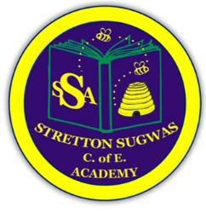

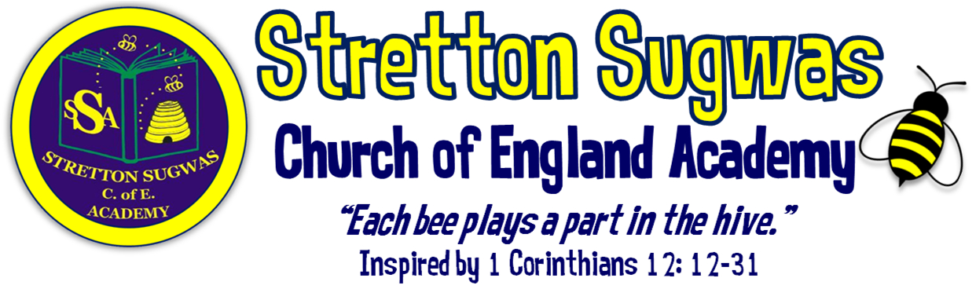

Subject Leader Action Plan: Computing
How can we help all stakeholders at Stretton to “Bee”long, “Bee”lieve in their skills and “Bee”have in a way that helps others?
Scriptural Background: 1 Corinthians 12 v12-31 (NIV)
Just as a body, though one, has many parts, but all its many parts form one body, so it is with Christ. ¹³For we were all baptized by one Spirit so as to form one body-whether Jews or Gentiles, slave or free-and we were all given the one Spirit to drink. ¹⁴Even so the body is not made up of one part but of many. ¹⁵Now if the foot should say, "Because I am not a hand, I do not belong to the body," it would not for that reason stop being part of the body. ¹⁶And if the ear should say, "Because I am not an eye, I do not belong to the body," it would not for that reason stop being part of the body. ¹⁷If the whole body were an eye, where would the sense of hearing be? If the whole body were an ear, where would the sense of smell be? ¹⁸But in fact God has placed the parts in the body, every one of them, just as he wanted them to be. ¹⁹If they were all one part, where would the body be? ²⁰As it is, there are many parts, but one body. ²¹The eye cannot say to the hand, "I don't need you!" And the head cannot say to the feet, "I don't need you!" ²² On the contrary, those parts of the body that seem to be weaker are indispensable, ²³ and the parts that we think are less honourable we treat with special honour. And the parts that are unpresentable are treated with special modesty, ²⁴ while our presentable parts need no special treatment. But God has put the body together, giving greater honour to the parts that lacked it, ²⁵ so that there should be no division in the body, but that its parts should have equal concern for each other. ²⁶ If one part suffers, every part suffers with it; if one part is honoured, every part rejoices with it.²⁷ Now you are the body of Christ, and each one of you is a part of it. ²⁸ And God has placed in the church first of all apostles, second prophets, third teachers, then miracles, then gifts of healing, of helping, of guidance, and of different kinds of tongues. ²⁹ Are all apostles? Are all prophets? Are all teachers? Do all work miracles? ³⁰ Do all have gifts of healing? Do all speak in tongues^{[d]}? Do all interpret? ³¹ Now eagerly desire the greater gifts.

Action Plan Summary

Based on evidence from monitoring, feedback and school priorities, the top four priorities for this subject are:
1.Embed robust assessment and moderation in Computing using Arbor and triangulation.
2.Stretch more able pupils through challenge tasks and deeper digital thinking.
3.Broaden computing opportunities through cross-curricular links and digital showcases.

4. Develop pupils’ digital vocabulary and oracy, aligned with Voice21.

Subject Lead: Ben Ford
Date: September 2025

Priority 1: Assessment (linked to SDP Target 1)

SMART Target:
By July 2026, all staff will implement consistent computing assessment using Arbor and triangulation (book looks, pupil voice, lesson observations), with moderation at least twice per year.
Rationale | Success Criteria | Actions | Who | Resources | Timescale | Monitoring | Reporting
Need for robust, consistent assessment across foundation subjects. Staff new to role require clarity. Arbor must capture data effectively. | • 100% staff trained on computing assessment.  • 2 moderation sessions completed.  • Termly Arbor entries completed.  • Triangulation evidence gathered twice per term. | • Train staff on computing assessment.  • Use Kapow’s assessment tools.  • Input termly data into Arbor.  • Triangulate using pupil work, voice, and lesson observations. | Subject Leader, SLT | Kapow assessment tools, Arbor, staff training time | Sept 2025 – July 2026 | Termly monitoring by subject leader & SLT | Staff meeting feedback; governor reports

Priority 2: Stretch More Able Pupils (linked to SDP Target 2)

SMART Target:
By July 2026, 90% of more able pupils will demonstrate deeper digital thinking through challenge tasks, coding extensions, and problem-solving activities.
Rationale | Success Criteria | Actions | Who | Resources | Timescale | Monitoring | Reporting
SDP focus on challenge. Need to evidence depth in computing. | • CPD on challenge delivered by Term 2.  • 100% Kapow units include “Extension / More Able” tasks.  • 80%+ pupils report challenge.  • 30%+ work samples show deeper thinking. | • Deliver CPD on digital challenge.  • Embed extension tasks in Kapow planning.  • Use pupil voice to evaluate challenge.  • Monitor books and digital portfolios. | Subject Leader, All staff | Kapow, CPD resources | Sept 2025 – July 2026 | Mid-year & end-year monitoring | Governor reports; staff meeting feedback

Priority 3: Cross-Curricular Links & Digital Showcase

SMART Target:
By July 2026, computing will be embedded in at least 3 other subjects, with pupils showcasing digital work via Microsoft Teams and at least one public exhibition.
Rationale | Success Criteria | Actions | Who | Resources | Timescale | Monitoring | Reporting
Computing should enhance other subjects and be visible. | • 3+ subjects show computing integration.  • 80%+ classes use Teams to showcase work.  • At least one digital exhibition held. | • Audit computing use across subjects.  • Train staff on Teams for evidence capture.  • Plan digital showcase event.  • Monitor cross-curricular planning. | Subject Leader, teachers | Microsoft teams, devices | Sept 2025 – July 2026 | Mid-year review of partnerships & visits | SLT reports, pupil feedback

Priority 4: Oracy & Vocabulary (linked to SDP Target 6 – Voice21)

SMART Target:
By July 2026, 80% of pupils will confidently use Tier 2 and Tier 3 Computing vocabulary in speech or writing, with oracy tasks embedded in 100% of Computing lessons.
Rationale | Success Criteria | Actions | Who | Resources | Timescale | Monitoring | Reporting
SDP focus on oracy and Voice21. Computing vocabulary is essential for digital literacy. | • Vocabulary progression list for Computing produced by Term 1.  • 100% of lessons include structured oracy task.  • 80%+ pupils use Tier 2/3 vocabulary accurately in pupil voice/written work.  • Vocabulary seen in books/displays. | • Identify and display key computing vocabulary.  • Provide sentence stems for digital discussion.  • Embed oracy tasks in Kapow lessons.  • Monitor vocabulary use in pupil work. | Subject Leader, All staff | Vocabulary lists, Voice21 strategies | Sept 2025 – July 2026 | Lesson observations; pupil voice | Termly subject leader reports; governor updates

Implementation Timeline
- Term 1: Staff training on assessment; vocabulary list developed; CPD on challenge scheduled; Teams training begins.
- Term 2: First moderation; triangulation; cross-curricular audit; pupil voice on challenge.
- Term 3: Second moderation; digital showcase; review vocabulary/oracy; governor visit.

Research & Evidence Base
- Assessment: Moderation using shared frameworks (e.g. Pollen8) increases reliability of judgements and staff confidence (Ofsted; EEF).
- Retrieval & Spiral Curriculum: Kapow’s spiralled structure builds secure memory and progression, supported by cognitive science research (EEF, 2022).
- Challenge for More Able: Enquiry-based, higher-order questioning and critique tasks lead to improved outcomes for more able learners (DfE Challenge the Most Able, 2015).
- Local Cultural Links: Research highlights that local and cultural relevance improves engagement and attainment (EEF Toolkit – Arts Participation +2 months).
- Oracy & Vocabulary: Explicit vocabulary instruction and structured talk activities improve comprehension and attainment across subjects (EEF Oral Language Interventions, +6 months).

Impact Statement – Art 2025–26
By July 2026, computing at Stretton Sugwas CE Academy will be inclusive, consistent and inspiring. Robust assessment via Arbor and triangulation will ensure accurate tracking and support. More able pupils will be stretched through challenge tasks and coding extensions, with evidence of deeper thinking in digital portfolios. Computing will be embedded across subjects, enriching learning and enabling pupils to showcase their work through Microsoft Teams and public exhibitions. Vocabulary and oracy will be strengthened, with pupils confidently using digital language to explain, critique and present their ideas. These developments will ensure computing supports the school’s Christian vision: helping pupils to belong, believe in their digital skills, and behave in a way that uses technology to make a positive difference.

