Make a Difference Calendar
The intention of the calendar is to increase the impact of cultural events by making subject-specific and values-related links more explicit. This may provide a useful thread that runs through assemblies and may also compliment themes of religious festivals that fall within the timeframe.
Autumn
Sept | Oct | Nov | Dec
Social Action September | Black History Month | Peace and Protection Month | Christmas Countdown Of Hope
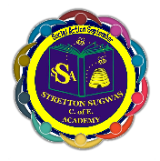
Organic September  International Day of Charity (5th)  National Read a Book Day (6th)*  Roald Dahl Story Day (13th)*  National Coding Week*  Int. Day of Democracy (15th)  Int. Ozone Layer Day (16th)  Great British Beach Clean Week  Recycle Week  Int. Day of Peace (21st)  Car Free Day (22nd)  European Day of languages (26th)*  Bike to School Week  Sporting Heritage Day (30th)*  Harvest | The Big Draw*  Int. Walk to School Month  Int. School Library Month*  Nat. Bullying Prevention Month  Day for Older Persons (1st)  World Animal Day (4th)  World Space Week (4th)*  National Poetry Day (6th)*  World Mental Health Day (10th)  Anti-slavery Day (18th)  World Food Day (18th)  UN Day (24th)  World Cities Day (31st)* | World Vegan Day (1st)  Stress Awareness Day (2nd)  Guy Fawkes/Bonfire Night (5th)  Youth Work Week (7th)  Science For Peace (10th)*  Remembrance (11th)  Inter-Faith Week (13th)*  Kindness Day (13th)  Anti-Bullying Week (14th)  Road Safety Week (14th)  International Day of Tolerance (16th)  Friendship Friday (18th)  Children in Need  Social media kindness day*  Geography week* | Disabled persons’  Abolition of slavery (2nd)  Christmas jumper day (9th)  Human Rights Day (10th)  Christmas/Advent  Hannukah
Spring
Jan | Feb | Mar | Apr
Religious Harmony Month* | Love and Respect Month | Women’s History Month | Save the Earth Easter
 |  | 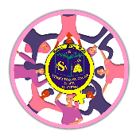
Epiphany (6th)  World religion day* (15th)  Veganuary  Human trafficking  International Day of Education (24th)  Holocaust Memorial Day (27th)*  Big Garden Birdwatch (27th)  Data Privacy Day (28th)* | Interfaith Harmony Week  Time to Talk Day (2nd)  Children’s Mental Health Week (4th)  Safer Internet Day* (7th)  Women and Girls in Science (11th)  Valentine’s Day (14th)  Random Acts of Kindness (17th)  Fairtrade Fortnight (20th)  Unicef Day for change | Veggie Month  International Women’s Day (1st)  Zero Discrimination Day (1st)  World Book Day (2nd)*  World Wildlife Day (3rd)  Commonwealth Day (13th)  Global Recycling Day (18th)  Mother’s Day (19th)  Lent  Shakespeare Day (20th)*  Earth Hour (25th) | Pet Month  Stress Awareness Month  International Book Day (2nd)*  Walk To Work (7th)  World Health Day (7th)  Earth Day  Great British Spring Clean  Holy Week
Summer
May | Jun | Jul | Aug
Mental Health Awareness Month | Diversity and Inclusion Month | Plastic-Free July | Safe Fun Summer
 |  | 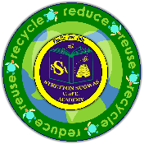 | 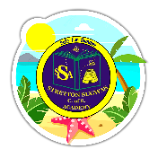
Walk to school  Local /Community History Day (1st)*  VE Day (8th)  Christian Aid week (14th)  Vegetarian Week (15th)  World Hunger Day (28th) | Pride Month  Environment Day (5th)  Ocean’s Day (8th)  Father’s Day (18th)  Refugee Week (19th)  Armed forces  Garden wildlife  Pentecost | Children’s art day*  Plastic bag free day (3rd)  Int. Day of Friendship (30th)

